OCEAN COUNTY
YOUTH SERVICES
COMMISSION
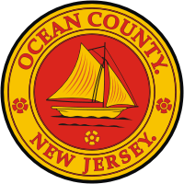

2018-2020
COMPREHENSIVE
PLAN & APPLICATION

COPY

