Affordable Housing
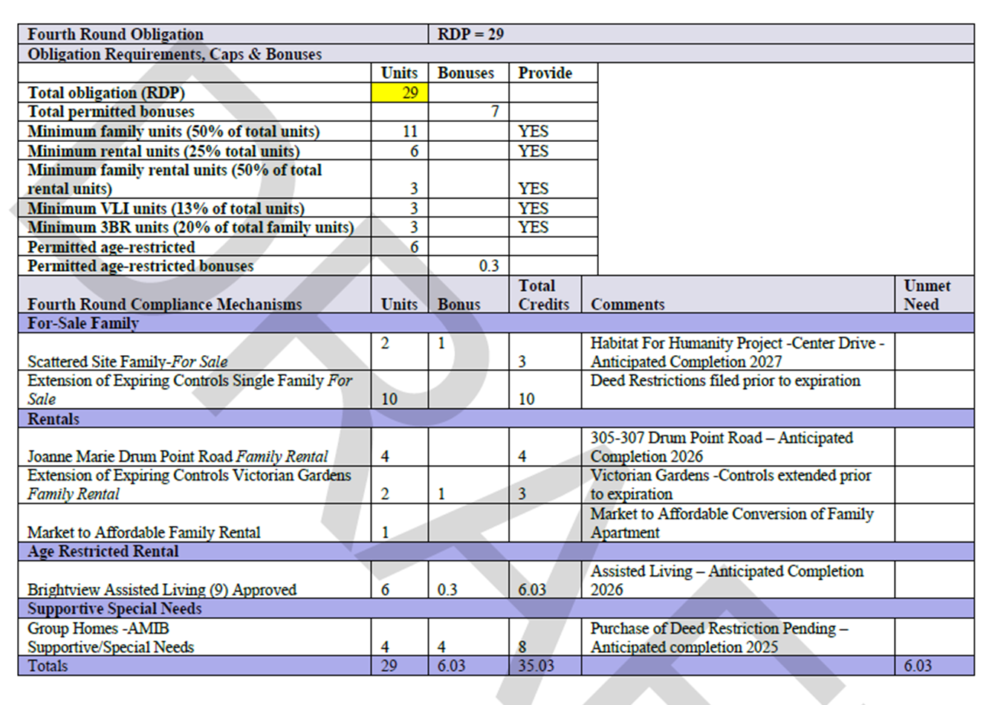
June 11, 2025 at 5pm is the Fair Share and Housing Plan Element Master Plan Hearing in the courtroom. Tara went over the draft plan and the draft ordinance. Tara will present the draft plan for consideration by the planning board to adopt the plan for submission to the NJDCA. The deadline for submission is June 30, 2025. The two main issues relative to the plan are:
The second part of compliance will be the Middle Housing Overlay Zone where the Township will create an overlay over existing zoning at motel/hotel/bungalow/cottage multifamily nonconforming and substandard properties to encourage redevelopment. There are approximately 300 units in these areas along Rt. 88 and Mantoloking Road that we hope will be replaced and create an opportunity for 1 out of every 5 units to be deed restricted as affordable. The Anchor Concrete site on Burn Tavern Road will also be included in the overlay zone.
Escrow Fees
Township Planner Tara Paxton is requesting the Township consider escrow fees. There is a growing problem with the billing for applications to the Zoning Board of Adjustment and Planning Board. The Land Use Department has a variety of application types to the Zoning Board in our current fee schedule (24029) but the issue is limited to the following hardship variances:
Accessory Bulk Variances - $200 application fee – these are for sheds, decks, fences and pools. No escrow funding is required for these applications.
Principal Bulk Variances - $250 application fee and a $2,000 escrow fee – these are for applications where setbacks are not met and require “C” variances. These typically involve single-family residential structures.
These applications are becoming increasingly more complicated to review and for the attorney, engineers and out staff due to impervious cover, flooding, grading and drainage and neighborhood conflicts. They are taking up more time due to objectors and technical reviews than we have funding to cover in the application or escrow funds. This results in staff members having to request additional funds of resident’s multiple times to cover the professional fees. This has caused many contentious conversations with the residents and applicants. In some cases, we have ad to result to billing the Rider Account to cover these fees because residents have refused to send more funding. This is the second issue – our Rider Account is being depleted from the billing for the Accessory Bulk applications because there is no escrow to be billed.
Planning staff have researched surrounding communities and have discovered that we are the only municipality that does not have an escrow fee for the Accessory Bulk applications and our Escrow fee is low in comparison. They recommend the Township implement an Escrow Fee of $500 for the Accessory Bulk applications and raise the Escrow Fee for the Principal Bulk applications to $2,500.

Photovoltaic Fees Wording
Construction Official Mike Juzefyk requested a change in the fee schedule for solar applications. The New Jersey Department of Community Affairs, Division of Regulatory Affairs, is requiring changes to the wording of the ordinance. There are no proposed changes to the fees.
The required changes are highlighted below in blue:

(8) Photovoltaic (solar) installations shall be charged by individual items. (microinverters, inverters, Disconnects, Combiner Box, and Photovoltaic Panels) for 1 to 50 Photovoltaic Panels the fee shall be $100.

(a) The fee for the Photovoltaic individual panels shall be:
Photovoltaic (solar) systems: For one to 50 kilowatts, the fee shall be $100

[1] For one to 50 Photovoltaic Panels, the fee shall be $100.
[2] Fifty-one to 100 Photovoltaic Panels, the fee shall be $250.
[3] Greater than 100 Photovoltaic Panels, the fee shall be $750.

(b) Inverter fees, other than micro-inverters (inverters under one kilowatt), shall be based on the kilowatts as follows:

[1] From one kilowatt to 10 kilowatts, the fee shall be $25.
[2] From 11 kilowatts to 45 kilowatts, the fee shall be $65.
[3] Over 45 kilowatts, the fee shall be $225.

(c) Micro-inverters, inverters with a rating of less than one kilowatt, the fee shall be a flat fee of $75, regardless of the number of micro-inverters.

(d) Disconnects and combiner panels: Disconnect and combiner box panel fees are based on the ampere rating as follows:

[1] For one to 100 amperes, the fee is $75.
[2] For greater than 100 to 225 amperes, the fee shall be $180.
[3] For greater than 225 to 600 amperes, the fee shall be $275.
[4] For greater than 600 amperes to 1,000 amperes the fee shall be $650.
[5] For greater that 1,000 amperes, the fee shall be $700.

The Committee agreed to amending the ordinance.

