Land Use Committee
September 9, 2025

Attendees: Council President Derrick Ambrosino, Mayor Lisa Crate, Joanne Bergin, Kevin Starkey and Tara Paxton.
Guest: Township Engineer Elissa Commins, Affordable Housing Attorney Robin LaBue, Esq.

Affordable Housing
Challenges to Fair Share plans were due to be filed by August 31. Some are still coming in, Robin said. Fair Share Housing filed something in every municipality, she said. Fair Share Housing are housing advocates. They want to see documentation about extension of controls, etc.

Fair Share Housing thinks it can be resolved if we meet and hash it out, she said. Robin and Tara will schedule a meeting as requested.

Robin reported there are two substantive challenges, claiming that the Township did the calculations incorrectly.

The first challenge is regarding 100 Drum Point Road, the subject of a Board application for approval of 60 single-family homes. That application was denied. The challenge cited the need to include that in our Plan, but it was not an approved project, and without that approval, could not be included. To include it prior to the approval would have been improper, Tara said. Including it could have swayed the application, she said,

Robin will get an opposition filed with appointed adjudicators.

The second challenge is regarding 975 Burnt Tavern Road – Anchor Concrete. The owners are currently renting it out to a contractor. They were looking to develop the site with 11 residential buildings which would have equated to 400 new single-family units on 11 acres (40 units per acre). The site is closer to 23 acres but there are environmental restraints on some of the acreage.

Tara said they can keep the previous use which was a storage yards for contractors.

Robin explained that the two challengers went through the plan bit by bit and listed them thoroughly. We are going to respond item by item and hope for dismissal. The minimum amount permitted is just that – minimum amount permitted - which is within our rights.

Township zoning does not allow for what they want - that’s why they’re objecting, they’re attacking our overlay zone. The property is in our overlay zone.

The developers of 100 Drum Point Road can appeal in Superior Court or request a waiver from the Board of Adjustment.

Robin is hoping to meet with Fair Share Housing within 2 weeks.

Street Vacation Law-Win Court

There is property on Law-Win Court that was purchased, subdivided, but never built.

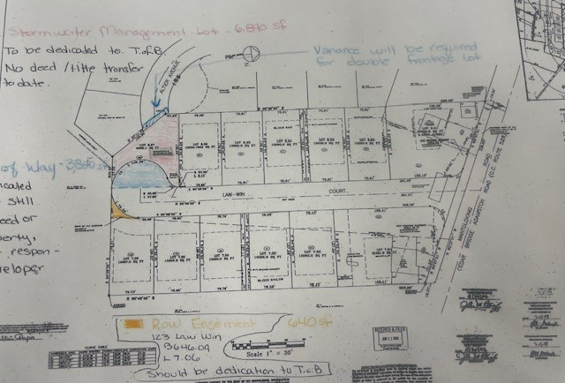
Arya properties purchased the property behind it, extended Law-Win Court and built those homes. Two maps were filed.

The applicant’s attorneys is requesting the Township vacate the portion of the roadway that will provide a buildable lot. The gold colored piece is right of way easement.

Elissa does not have the agreement that goes with the easement so she doesn’t know the intent of said easement.

Its already a right of way easement so if someone owns it, he/she might want to get rid of it so they’re not paying taxes, Elissa said.

It’s going to show up on a title search if we’re going to give up the roadway we want it to be a clean transaction, she added.
The right of way is an actual road. Elissa said the easement has to be amended to allow a specific purpose, with the Township having no responsibility to maintain the right of way.

Elissa also said the Township has not released the bond to Arya Properties yet, and we can’t consider this street vacation until we release the bond.

In the map above, the blue & red areas will become one lot.

Elissa wants a revised map provided as the Township cannot vacate something we don’t own.

Ken Smith – Hannan Court

Tara reported that she and Elissa were approached by Ken Smith regarding Hannan Court.

The Township owned lots 2 and 1. Mr. Smith wants to swap a Township owned lot to build a detention facility they are required to provide for stormwater. This area is off of Dunbeck Road, which is behind Greenbriar 1.

The street vacation plus the Township owned lots makes 6 lots, of which 2 would be required to be for affordable housing. The developer’s response that 8 lots cannot absorb 2 affordable housing units. Instead, the developer offered one unit. Township ordinance says 1 unit for every 5 units as well as a contribution to the Affordable Housing Trust Fund.

The other option was to create duplexes.

The Committee is not in favor.

