The Brick Township Board of Adjustment
Regular Meeting was held on April 8, 2026 in the Municipal Building
The meeting was called to order at 7:00 pm.

Notice of the Public Meeting was read by Chairman Chadwick. He led the Salute to the flag and the roll was called.

MEMBERS PRESENT
David Chadwick
Wendy Evegan
Mike Jamnik
Brian Formica
Glenn Fuchs
Darren Caffery
Eileen Della Volle
Jennifer Luddy- Alt
Jesse Fusco- Alt

MEMBERS ABSENT

ALSO PRESENT
Emily Weiner, Esq.
Drew Pavlick, PE, CFM
Jordan Rizzo, PE, CME
HGA Planner, Lindsey Massih
Christopher Romano, Zoning Officer
Bright View Engineering Traffic Consultants
Denise Sweet, Court Reporter
Pamela O’Neill, Secretary

The Board Professionals were sworn.

Vouchers-

OLD BUSINESS:

Case Number:
BA-3583-10/2025
Gina Angelico
114 Jeannette Dr.
Block 27, Lot 95

A motion was made by Darren Caffery to approve and seconded by Mike Jamnik.
Board members voted- Mike Jamnik, Wendy Evegan, Brian Formica, Darren Caffery, Jess Fusco and David Chadwick.

NEW BUSINESS:

Case Number:
BA-3577-9/2025
Peter King
1 Island Dr.
Block 878.01, Lot 18
Bulk Variance

In attendance on behalf of the Applicant:
Peter King- Owner and Applicant

Description of the Application:
Requesting permission to allow the construction of a set of stairs located on the front westerly side of the elevated deck to the property’s ground deck as per the revised step layout on plot plan of 9.5.2025. The applicant has provided pictures and plans. Required is a 15’ setback and proposed is 1’.

Testimony was provided by:
Peter King – Owner and Applicant

Chairman opened to the public. No one from public commented/emailed.
Chairman closed the public session.

A motion was made by Mike Jamnik to approve and seconded by Wendy Evegan. Board members voted- Mike Jamnik, Wendy Evegan, Brian Formica, Glen Fuchs, Darren Caffery, Jess Fusco and David Chadwick.

*W/ Conditional 3’ landing at the end of the stairs.

Case Number:
BA-3585-C-11/2025
Karen & Patrick DelleCava
119 E. Granada Dr.
Block 211. 13, Lot 17
Bulk Variance

In attendance on behalf of the Applicant:
Karen & Patrick DelleCava- Applicant and Owner
Christopher LaMonica- Esq.- Attorney for the Applicant
Brian M Collis- Architect for the Applicant
Anthony Donnatello,Lindstrom, Diessner & Carr- Engineer for the Applicant

Description of the Application:
Construct one-story addition for storage. Proposed front setback is 13.6’ required is 20’. The side setback proposed is 14.7’ and required is a combination of 5’/12’. The rear proposed setback is 19.8’ and required is 15’. The C (1) hardship due to lot width. C (2) Benefits outweigh detriment, if any. Bringing down the impervious coverage from 73.4% back to 70%. Mr. Donnatello spoke about the photographs he submitted. Will comply with FEMA compliance as well with flood vents. Mr. Collis spoke about the proposed storage area and the covered porch as well. They want the one-story addition to look like it is part of the house. Spoke about substantial changes to the driveway. Agreeing to the 18’ at the width of the road. Moving the driveway farther away from the corner property for safety reasons. Easier to back in and out.

Testimony was provided by:
Patrick DelleCava- Applicant and Owner
Christopher LaMonica- Esq.- Attorney for the Applicant
Brian M Collis- Architect for the Applicant
Anthony Donnatello -Engineer for the Applicant

Engineer is showing an exhibit A-1 (4) photographs of the yard and neighborhood that were photographed back in February.

Chairman opened to the public. No one from public commented/emailed.
Chairman closed the public session.

*Condition to have an 18’ driveway opening instead of 20’

A motion was made by Darren Caffery to approve and seconded by Mike Jamnik. Board members voted-Mike Jamnik, Wendy Evegan, Brian Formica, Glen Fuchs, Darren Caffery, Jess Fusco and David Chadwick.

Case Number:
BA-3580-C-10/2025
James & Catherine Wallace
32 Stratford Dr.
Block 903.16, Lot 9
Bulk Variance

In attendance on behalf of the Applicant:
John J Jackson, Esq. – Attorney for the Applicant
Brian Collis- Architect for the Applicant

Description of the Application:
Applicant seeks to construct an addition to the existing single-family home. The property is on a corner lot which has two frontages. The unique characteristics of the property presents a hardship for the Applicant to fully comply with the Zoning ordinance. The variance relief far outweigh any detriments, of which there are none. The design represents a good civic design with adequate air, light and open space on the property, and it provides an aesthetic upgrade to the property. The relief sought may be granted without substantial detriment to the Master Plan or the Zoning ordinance. Mr. Collis the Applicant’s architect is recreating the garage the same width but it will be combined to make a larger kitchen and living room as well as another hall bath and master bathroom. We now have gables facing towards the street to define the front door more. This is an expansion of the existing house. The narrowest frontage is where the rear is and would comply if this was a side yard. But because it is a corner property, there are two frontages. Not going farther out where the original house is. The setbacks are on an angle to make this look like it was always a part of the house. All the work is being done away from the two frontages where the streets are.

Testimony was provided by:
John J Jackson, Esq. – Attorney for the Applicant
Brian Collis- Architect for the Applicant

Chairman opened to the public. No one from public commented/emailed.
Chairman closed the public session.

A motion was made by Darren Caffery to approve and seconded by Mike Jamnik. Board members voted- Mike Jamnik, Wendy Evegan, Brian Formica, Glen Fuchs, Darren Caffery, Jess Fusco and David Chadwick.

BA-3586-C-12/2025
Darrell Falkinburg
324 Tuscaloosa Lane
Block 901, Lot 12
Bulk Variance

In attendance on behalf of the Applicant:
Darrell Falkinburg- Owner and Applicant
John Jackson, Esq. – Attorney for Applicant
Gerry Spanola- Architect Group PC for the Applicant
Matthew Hockenbury- Engineer for the Applicant

Description of the Application:
Applicant seeks to construct a 2nd story addition, expansion of current bulkhead & screen in porch. Adding a balcony as well to the rear of the property. Also construct a deck with stairs and landing. Minimum required rear setback is 15’ whereas proposed deck is 10.4’ from the proposed bulkhead. Minimum required rear setback is 15’, whereas proposed spa is 10.4’ from proposed bulkhead. The side setback for (pool) is 4.8’ existing, whereas 5’ required.

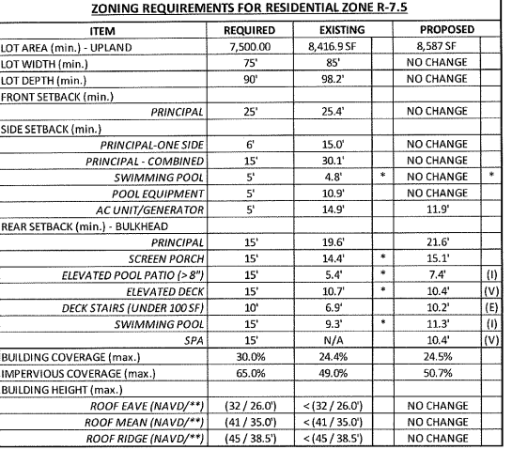

The Applicant has DEP approval to bump out the bulkhead by 24” which adds safety for the rear of the property. See attached chart with all the setbacks that are required and proposed.

Exhibit- Slideshow

Testimony was provided by:
Darrell Falkinburg- Owner and Applicant
John Jackson, Esq. – Attorney for Applicant
Gerry Spanola- Architect Group PC for the Applicant
Matthew Hockenbury- Engineer for the Applicant

Chairman opened to the public. No one from public commented/emailed.
Chairman closed the public session.

A motion was made by Darren Caffery to approve and seconded by Wendy Evegan. Board members voted- Mike Jamnik, Wendy Evegan, Brian Formica, Glen Fuchs, Darren Caffery, Jess Fusco and David Chadwick.

ADJOURNMENT

A motion to adjourn the meeting was made and all were in favor.

The meeting was adjourned.

Respectfully submitted by: Cheryce Moore

