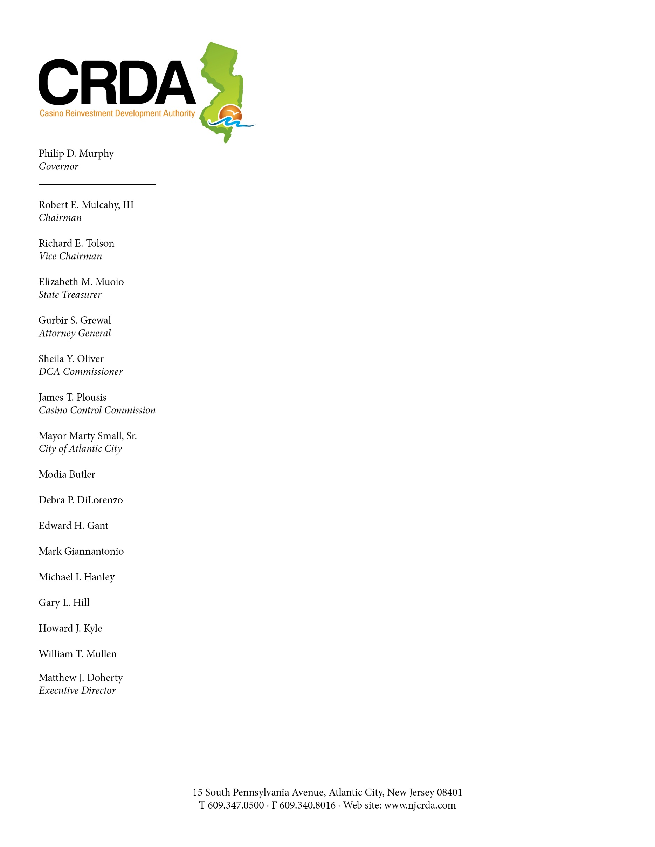

October 7, 2020

SENT VIA EMAIL ONLY
opra+request-17004-2545d4b2@requests.opramachine.com
Paul Dalnoky

Re: OPRA Request No. 2020-09-032

Dear Mr. Dalnoky:

The Casino Reinvestment Development Authority (“CRDA”) is in receipt of your above-referenced OPRA request.

While your OPRA request is vague and overly broad, and fails to identify with reasonable clarity the specific government records sought and/or requires research to be performed, enclosed is a document bates numbered OPRA 2020-09-032-001.

Sincerely,
Ellen Edwards
Ellen Edwards,
Paralegal/Records Custodian

cc: Monica E. de los Rios, Esquire
encl.

