September 6, 2023

VIA E-MAIL
Mr. M
opra+request-50833-015fc714@requests.opramachine.com

RE: OPRA REQUEST

Dear Mr. M:

We received your Open Public Records Act (OPRA) request via e-mail on August 30, 2023. Specifically, your request seeks:

“Please provide a copy of the full application for the installation of a well submitted in 1982 (application # 82-3482 for Block 4701, Lot 30).”

Attached are the documents responsive to your request.

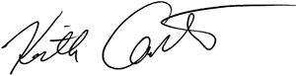
Sincerely,

Keith M. Carter
Regulatory Programs Specialist/Records Custodian

