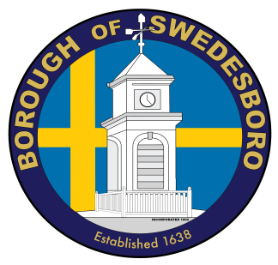
BOROUGH OF SWEDESBORO
COUNTY OF GLOUCESTER

Borough of Swedesboro
1500 Kings Highway
Swedesboro, NJ 08085
856- 467-0202 (Phone)
856- 467-5767 (Fax)
Date: 05/04/2021

Re: 59 Locke Avenue
Swedesboro, NJ 08085

OWNER: Cavalloro LLC
167 County House Road
Mount Royal, NJ 08061

The Borough of Swedesboro as of October 20, 2003 has adopted the International Property Maintenance Code 2003.

It has been brought to my attention or by my own observation that you may be in violation of 301.3 of the Property Maintenance Code which reads Vacant structures and land, All vacant structures and premises thereof or vacant land shall be maintained in a clean, safe, secure, and sanitary condition as provided herein so as not to cause a blighting problem or adversely affect the public health and safety.

The property on 59 Locke Avenue needs your immediate attention. Please contact me within ten (10) days with your plans for the above-mentioned property.

Very truly yours,

Keith Lamb
Code Enforcement Officer
856-467-0202

