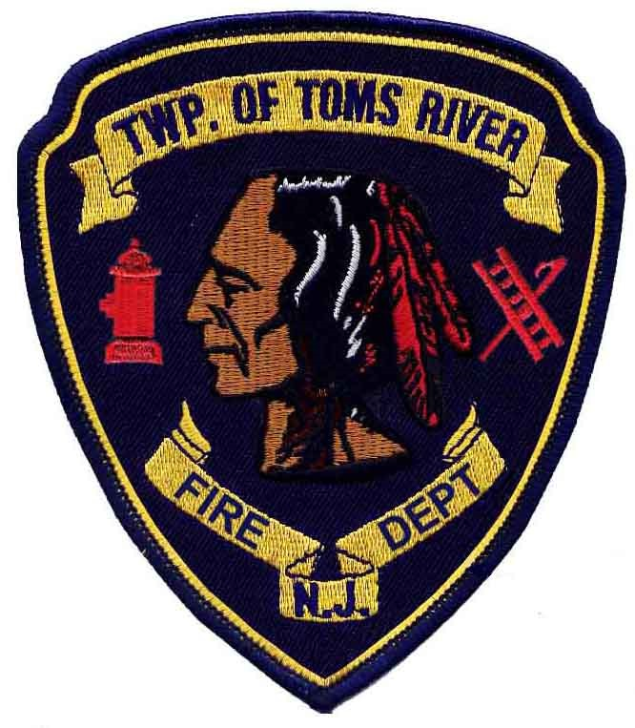
Toms River Township Fire Department
Standard Operating Guidelines
Guideline 9-06: Out of Service Units
Issued: 1-1-05
Reviewed |  | Revised | 4-27-09
 |  | Revised | 8-21-11  10-22-18
Purpose – This guideline shall be used in order to notify dispatchers and personnel of apparatus out of service.
Scope - All Department personnel
- Dispatcher Notification
  - When a unit is placed out of service the dispatcher should be notified.
  - All units that are out of service shall be listed “out of service” in the CAD using the radio log “oosrv”,
- Personnel Notification
  - When a unit is placed out of service the home company chief or officer may request the company be paged and notified of unit being out of service.
  - The dispatcher on a daily basis will make a radio announcement: 0700hrs and 1900 hours
“Alert Tone 1, time is ####, the following unit(s) are out of service (list the units out of service), Toms River Fire Department Operator ###.”
On Wednesday Alert Tone 2 will be used to provide the out of service message, using the following procedure:
Page 1 of 2
Toms River Township Fire Department
Standard Operating Guidelines
“This is a test of the evacuation tone, the following unit(s) are out of service (list the units out of service), Toms River Fire Department Operator ###.”
Seasonal units (boats, waverunners, quads) will be announced for one (1) week after they are taken out of service for the season.
- In the event there are no vehicles out of service, the dispatchers will conduct a radio test using the same procedures.

- When an out of service unit is placed back in service, the home company chief or officer may request the company be paged and notified of the unit being placed back in service.

Page 2 of 2

