TOMS RIVER TOWNSHIP FIRE DEPARTMENT  Standard Operating Guidelines |  |  |  |  | 
CHAPTER: 4 | SECTION: 06 |  | # OF PAGES: 6
SUBJECT: PROPANE PROP OPERATION

EFFECTIVE DATE: 3/01/2022 |  | BY THE ORDER OF: Director Toms River Fire Academy |  | SUPERSEDES ORDER #:

Purpose: The purpose of the policy to educate instructors on the safe operation of the propane props at the Toms River Fire Academy

Scope: All Instructors, Toms River Fire Academy

Procedure:
- Safety
  - A Level II instructor, certified by the NJ Division of Fire Safety must be present before any live burn evolutions can begin.
  - Safety Stations:
    - An instructor will always be at the safety station(s) during an active fire evolution.
    - Both safety stations should be staffed when using the vehicle fire prop.
    - The instructor operating the main safety station may also be the instructor that lights the fire with the lighting torch. After the fire is lit, the instructor will return to the main safety station before an attack on the fire can begin.
    - The instructor at the secondary station by the vehicle prop will control the propane to the prop. The instructor at the main station has a different angle of observation and will shut the prop down if any unsafe acts are noticed or any student or observer appears to be in danger.
    - If the prop is shut down due to a safety issue, a safety critique will take place and if and when it is safe to resume, the operation will continue.
- Propane Valves, Distribution and Operation:
  - Large Propane Cylinder (100lb)
    - When using the large propane cylinder both liquid and vapor may be used.
      - In the Tank field open the vapor (blue) valves on the tank ends.
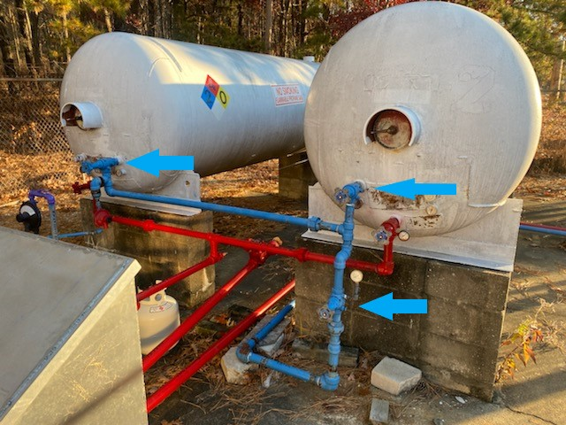

      - Open the liquid valves (red) on the tank ends, return lines to the tank
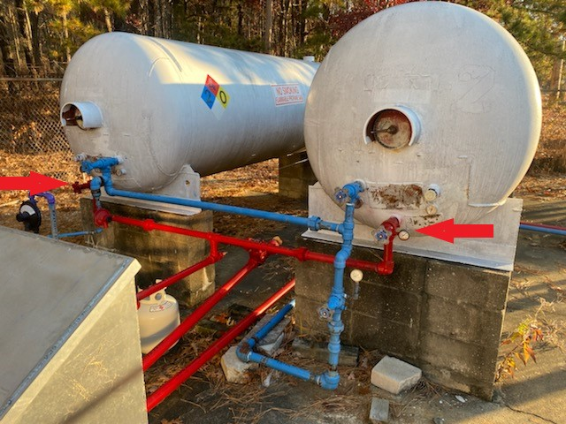

      - Open the feed valve (red) to the pump, coming from bottom of tanks
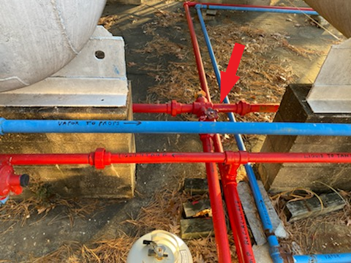

      - Open the main valve to the props (by the pump).
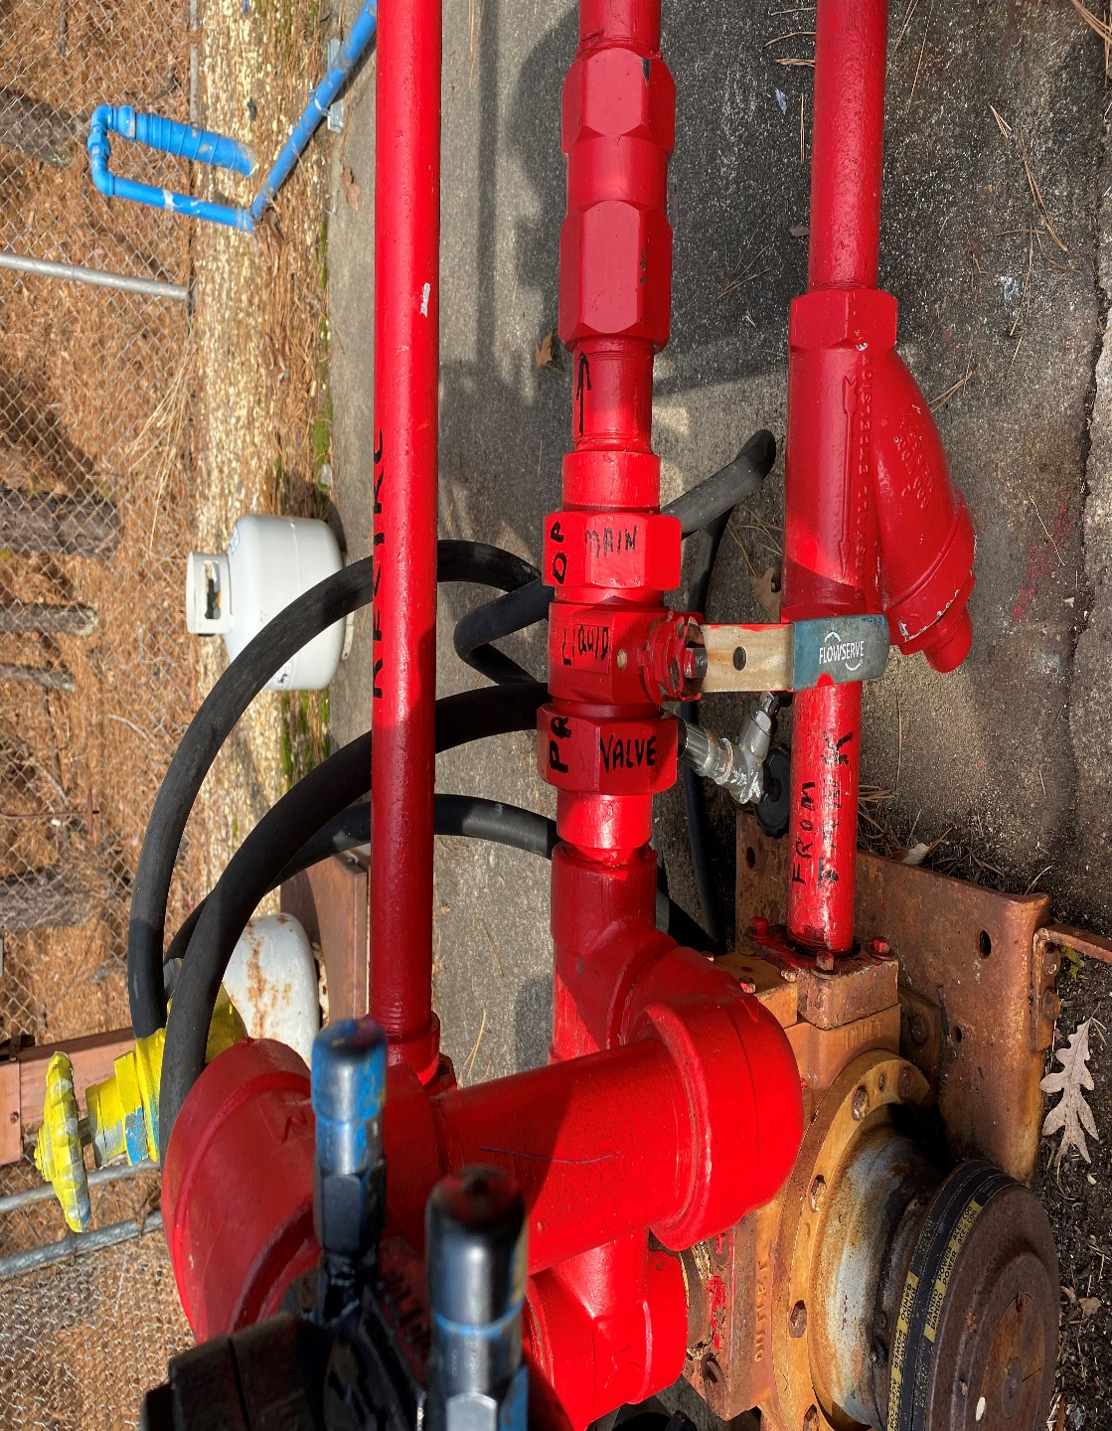

      - Just prior to lighting the fire the pump can be turned on. The switch is on the pole next to the pump. If there is going to be a long delay in-between burning evolutions the propane pump should be shut off during the idle time.
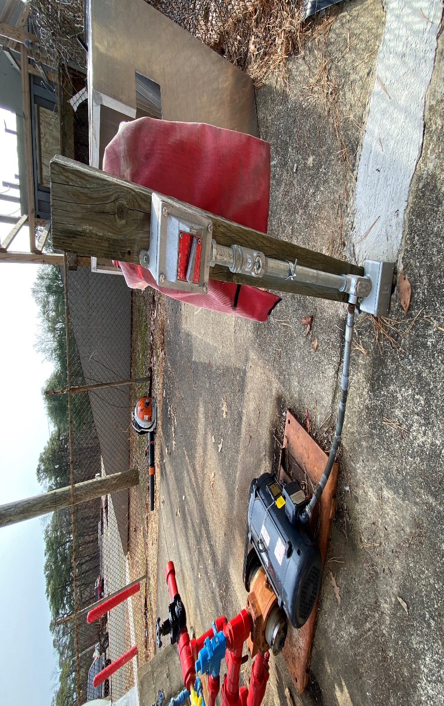
      - The main service disconnect for the pump is on the side of the classroom building by the exterior stairs. This will shut the power to the pump.
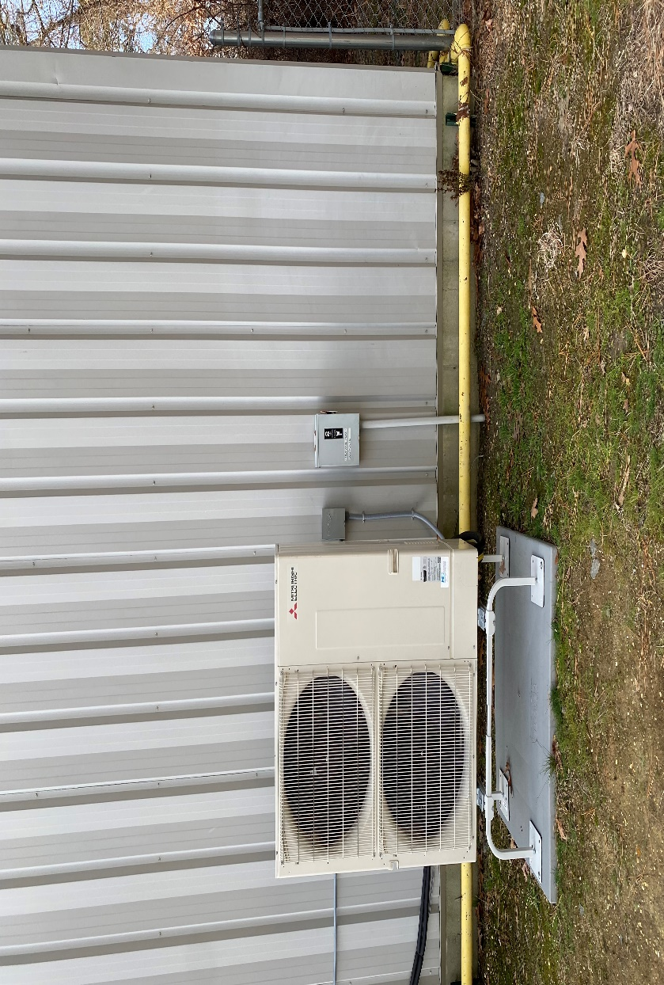
      - At the safety station open the vapor (blue) valve slightly so the fire can be lit. When the firefighter are ready to advance the vapor valve may be opened to increase the fire. At this time the liquid valve may be opened to add more fuel. Extreme caution should be used when adding liquid. Too much liquid may not vaporize quickly enough to burn and a liquid spill could take place creating an extremely dangerous situation.
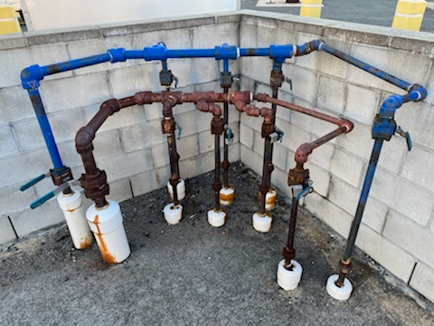
  - Vehicle Fire Prop
    - When using the vehicle fire prop only vapor will be used.
      - In the Tank field open the vapor (blue) valves from the tanks.
      - Open the main valve to the props (blue).
      - At the main safety station open the vapor valve to the vehicle prop.
      - At the vehicle safety station open the hood valve first a slight amount. Light the fire with the lighting torch. When the firefighters are ready to advance the other two valves (passenger comp, and truck) can be opened slightly so the fires can light. The valves can then be opened and closed to vary the volume of fire as the firefighters attack the fire.
  - Dumpster Fire Prop
    - When using the dumpster fire prop only vapor will be used.
      - In the Tank field open the vapor (blue) valves from the tanks.
      - Open the main valve to the props.
      - At the main safety station open the valve slightly so the fire can be lit with the lighting torch. When the firefighters are ready to advance the valve can be opened and closed to vary the volume of fire being attacked.
- Securing the Propane Props
  - When the evolutions are completed for the day/night the prop will be secured
    - All valves at both safety stations will be closed.
    - If the propane pump is on, it must be shut off.
    - All valves in the tank field will be closed.
- Reporting and Record Keeping
  - A TRFA Facility Prop use form must be completed when using the props.
    - The Lead Instructor for the evening or the Lead for that evolution must make sure the form is completed. If there are problems or damages with the props they must be noted on the form. Any damage, a separate incident report must be completed and submitted to the academy administrative staff.
    - All injuries must be reported in accordance with the injury reporting policy.
  - Tank volume checking procedures:
    - There is a place on the prop usage form for the volume of propane in the tanks and the volume used.
    - The tank volume should be checked before any evolution starts and at the end of all the evolutions.
    - To check the propane tank volume:
      - Gloves will be worn to check the tank volume to prevent frostbite as the liquid propane comes out of the center knob.
      - Turn the indicator handle in the upright position with the pointer facing up. The longer portion will be pointing down.
      - Open the knob on the center slightly until you hear vapor leaking out.
      - Slowly turn the handle downward towards the calibrated numbers on the tank gauge. You should hear vapor but not see any liquid.
      - When you start to see liquid (slight cloud coming out) close the knob.
      - Read the number that the pointer is facing. The reading is percentage of full. There is a conversion chart to convert the percentage to gallons to complete form.

