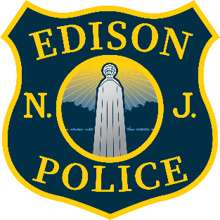
04/13/2026

Mr. Brisker,

The Edison Police Department Records Bureau received your Open Public Records Act (OPRA) request on 04/02/2026 for:

“Incident Report, Arrest Report, and BWC Footage from Case #: 22058612 Arrest Date: 9/29/2022”

OPRA allows public agencies to impose special service charges whenever the nature, format, manner of collation, or volume of a government record embodied in the form of printed matter to be inspected, examined, or copied pursuant to this section is such that the record cannot be reproduced by ordinary document copying equipment in ordinary business size or when fulfilling a request requires an extraordinary expenditure of time and effort. See N.J.S.A. 47:1A-5.c. Special service charges must be based upon the actual direct cost of providing the copy or copies.

OPRA mandates that the requestor shall have the opportunity to review and object to the charge prior to it being incurred. See N.J.S.A. 47:1A-5.c. As such, a detailed estimate is provided below:

The lowest level employee of the OPRA/Redaction Unit capable of fulfilling your request, their direct hourly rate is ($92.00) and the number of hours anticipated to complete your request is (90.92 hours). The total estimated special service charge would be ($5,604.64).

Kindly respond in writing with your acceptance or rejection of this estimated charge. We will not begin to process this request until we receive your written acceptance. If accepted a portion of the anticipated charge would need to be collected prior to completing any requested records.

If you reject the estimated charge and you wish to challenge the special service charge, you have a right to challenge the decision. At your option, you may either institute a proceeding in the Superior Court of New Jersey or file a complaint with the Government Records Council (GRC) by completing the Denial of Access Complaint Form. You may contact the GRC by toll-free telephone at 866-850-0511, by mail at P.O. Box 819, Trenton, NJ, 08625, by e-mail at grc@dca.state.nj.us, or at their web site at www.state.nj.us/grc. The GRC can also answer other questions about the law. All questions regarding complaints filed in Superior Court should be directed to the Court Clerk in your County.

Sincerely,

Records Bureau
Edison Police Department
100 Municipal Blvd.
Edison, NJ 08817
(P) 732-248-7446
https://www.edisonpolice.org/records-bureau/


