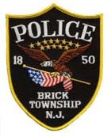
BRICK TOWNSHIP POLICE DEPARTMENT
401 CHAMBERS BRIDGE ROAD, BRICK, NJ 08723 OCEAN COUNTY, NEW JERSEY

INTEROFFICE MEMORANDUM

TO: Jessica Larney

FROM: Lt. Joshua Jenssen

SUBJECT: OPRA 815-26

DATE: June 9, 2026

In response to OPRA 815-26:

See Attached.

