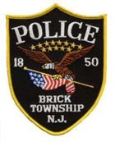
BRICK TOWNSHIP POLICE DEPARTMENT
401 CHAMBERS BRIDGE ROAD, BRICK, NJ 08723 OCEAN COUNTY, NEW JERSEY

INTEROFFICE MEMORANDUM

TO: Jessica Larney

FROM: Lt. Joshua Jenssen

SUBJECT: OPRA 590-25

DATE: April 15, 2025

In response to OPRA 590-25:

- Attached is the Incident Search List requested
- Attached is the Ticket Search List
- Attached is the Arrest Report Logs
- Attached are the requested incidents.
- As of March 1, 2025, our accident reports are created in the NJ Crash Records state portal. We are unable to search our system in the previously provided format.

