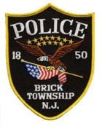
BRICK TOWNSHIP POLICE DEPARTMENT
401 CHAMBERS BRIDGE ROAD, BRICK, NJ 08723 OCEAN COUNTY, NEW JERSEY

INTEROFFICE MEMORANDUM

TO: Jessica Larney

FROM: Lt. Joshua Jenssen

SUBJECT: OPRA 1664-24

DATE: November 14, 2024

In response to OPRA 1664-24:

See Attached

