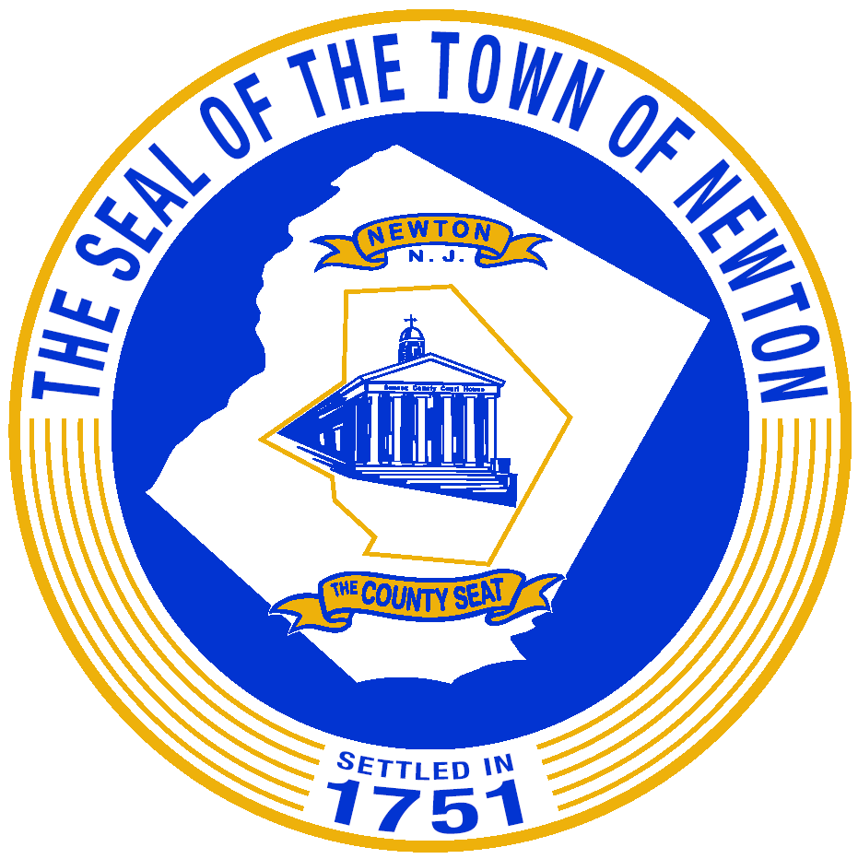
TOWN OF Interoffice Memorandum
Celebrating 50 years of Council- Manager Plan of Government OFFICE OF THE MAYOR

TO: Janien Roberts
FROM: Kat Walker
DATE: November 2, 2020
SUBJECT: OPRA - Tracking # 2020-286
The Planning and Zoning Department has the attached information pertaining to this OPRA request.
Regards,

Kathryn Walker
Town of Newton
Administrative Clerk
Community Development/Planning & Zoning/Recreation

