November 28, 2017

VIA E-MAIL
Ask NJ Media Co.
opra+request-367-75a83df4@requests.opramachine.com

RE: OPRA REQUEST

Dear Sir or Madam:

We received your Open Public Records Act (OPRA) request via e-mail on November 20, 2017. Specifically, your request seeks:

“Copies of all OPRA requests from August 1, 2017 to November 20, 2017.”

Attached are documents responsive to your request.

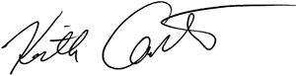
Sincerely,

Keith M. Carter
Regulatory Programs Specialist/Records Custodian

