Northern Burlington County Regional School District
160 Mansfield Road East
Columbus, New Jersey 08022-9742
Telephone: 609-298-3900 Fax: 609-298-3154
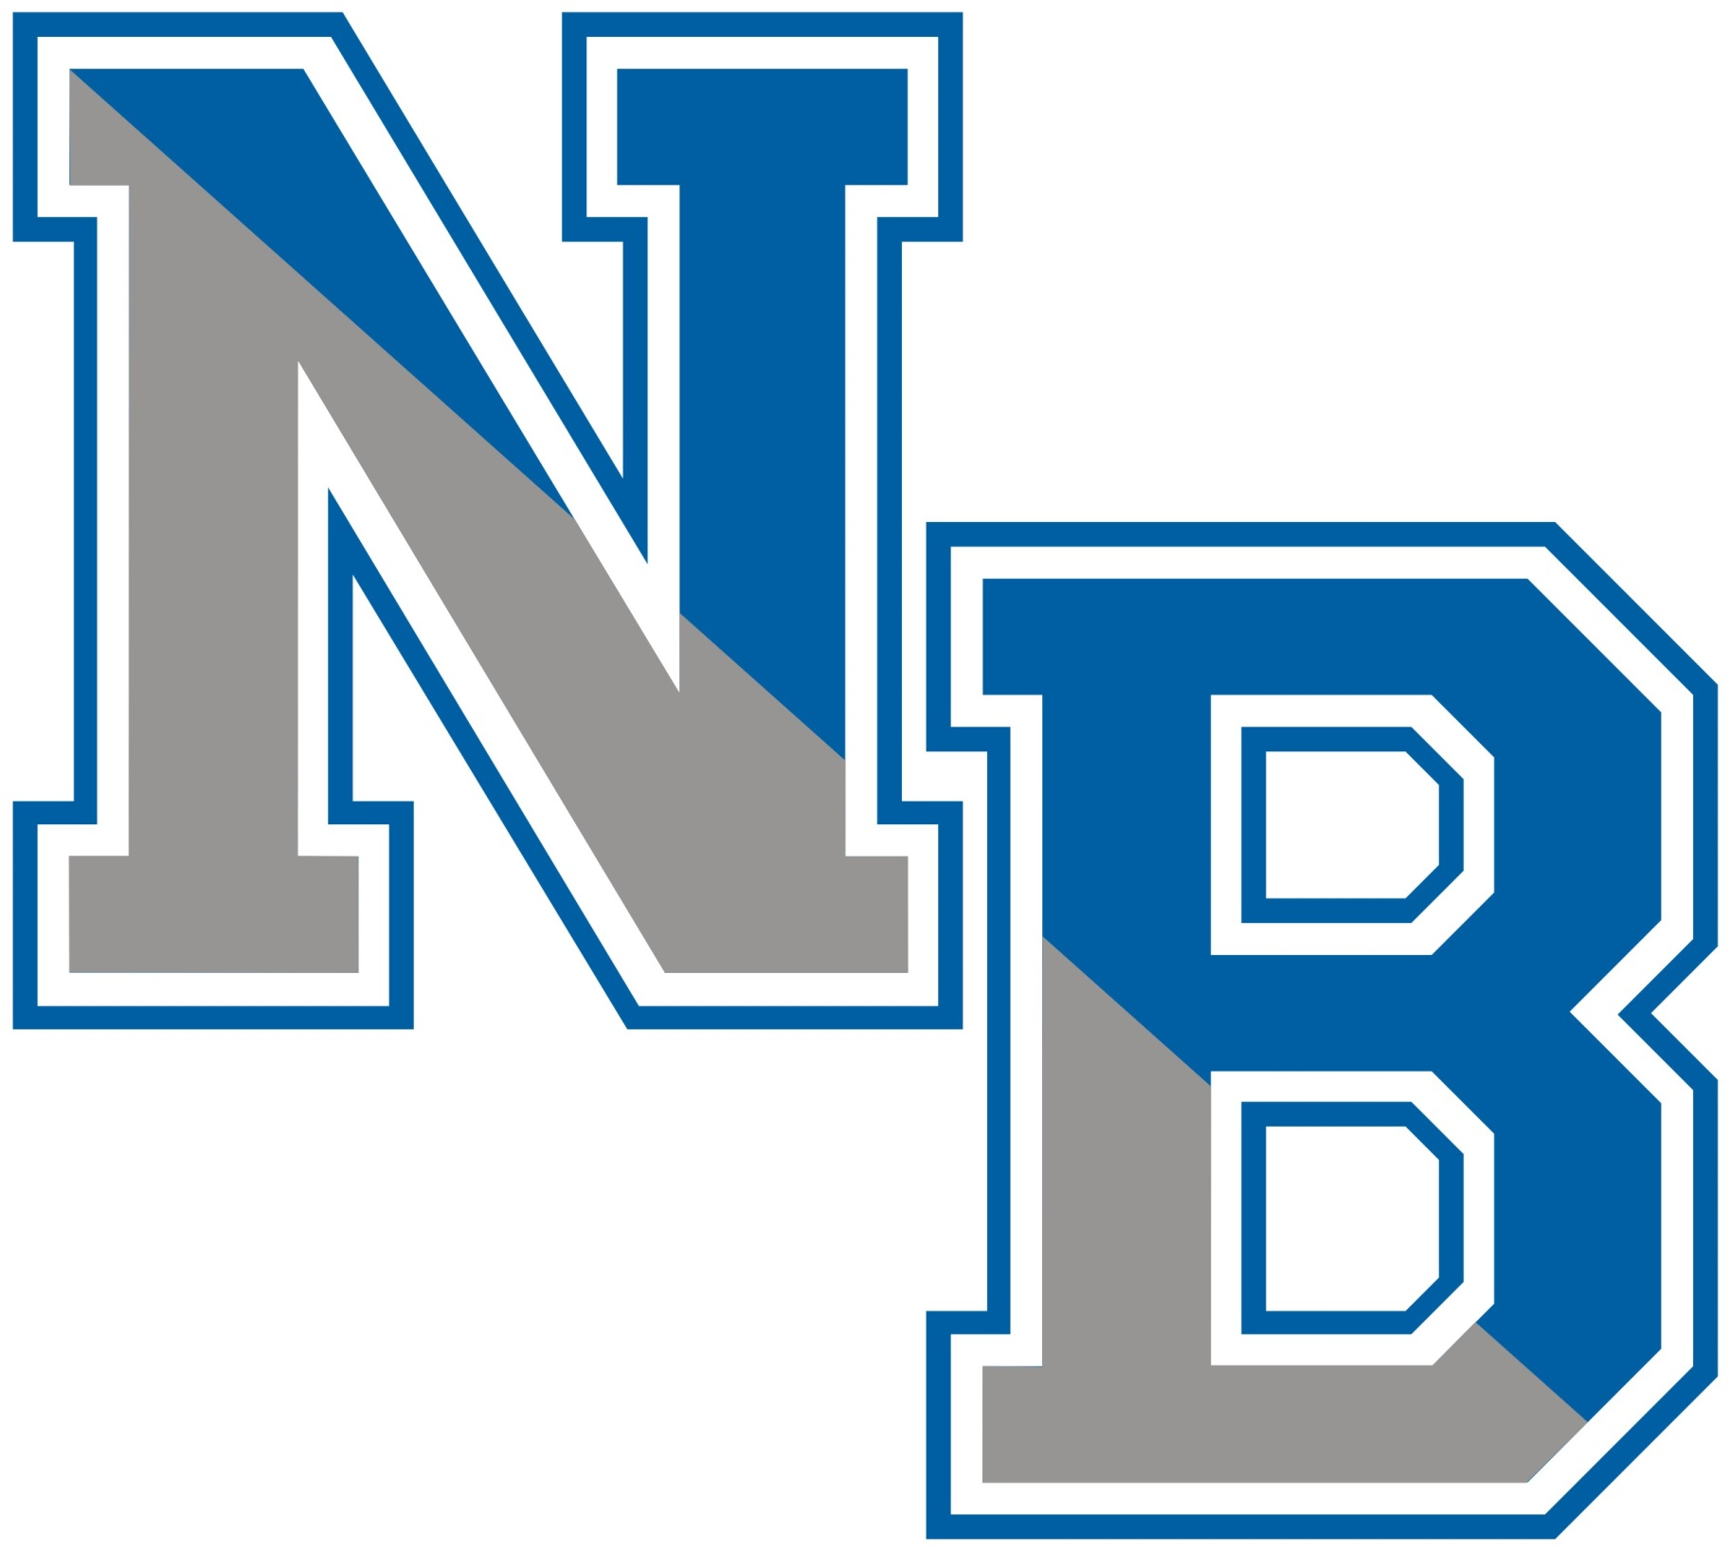
Dr. Andrew Zuckerman Mr. Richard Kaz
Superintendent of Schools Business Administrator /Board Secretary
(609) 298-3900 x 2006 (609) 298-3900 x 2080

District Web Page
www.nburlington.com

November 22, 2023

Anon OPRA
c/o opra+request-55239-798eaa42@requests.opramachine.com

Re: November 13, 2023 OPRA request

Dear Anonymous,

The Northern Burlington County School District received your OPRA request dated November 13, 2023. The District provides the following response in the time permitted under the Law:

Your request sought:

- All OPRA requests by Angela Reading and resulting information provided to Angela Reading between the dates of 1/1/2022 and 11/13/2023

Response: Please find attached responsive records.

- All OPRA requests by Angela Reading and resulting information provided to Nicole Stouffer between the dates of 1/1/2022 and 11/13/2023

Response: A search of the District’s records revealed no responsive records.

- All OPRA requests by Hope Grindlinger and resulting information provided to Hope Grindlinger between the dates of 1/1/2022 and 11/13/2023

Response: Please find attached responsive records.

This communication and the attached records complete your OPRA request.

Sincerely,

Richard Kaz,
Business Administrator

Attachments
cc: George M. Morris, Esq.

