In order to view the last auction results just go to the following address and hit the results link on the left hand side.

https://eastorange.newjerseytaxsale.com

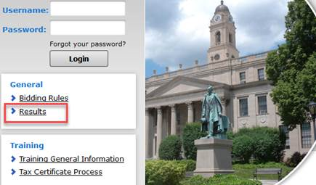

In order to see past auction results you would need to log in with your username and password.

Then click on the downloads button and the past years results are there for download.

