PERMIT HISTORY
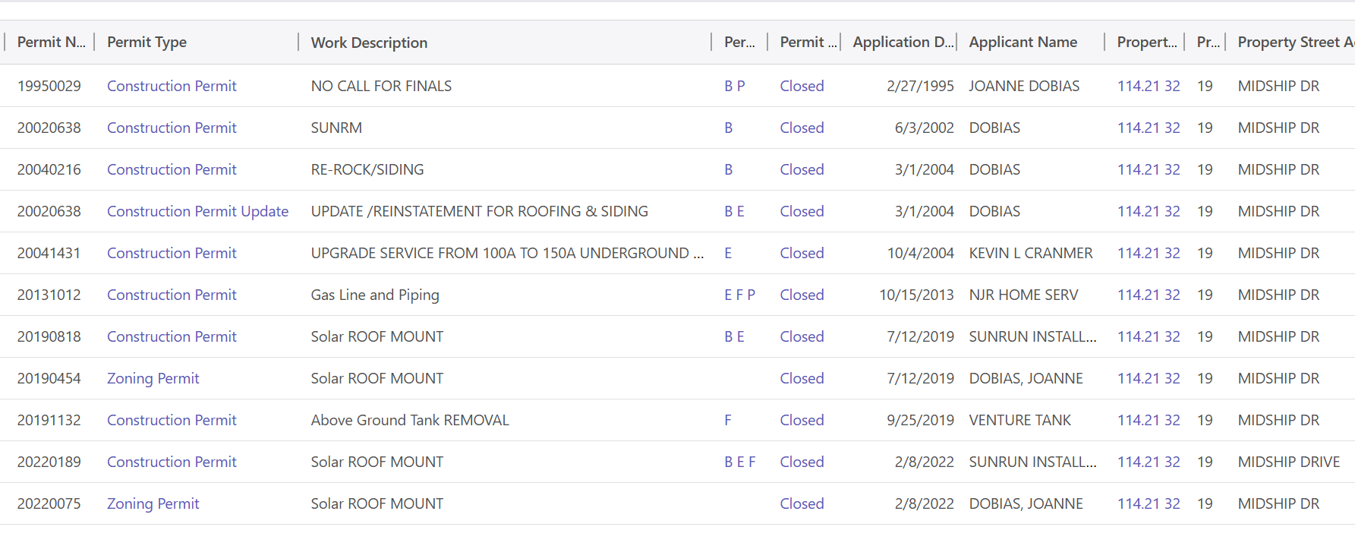
NO PROPERTY DAMAGE FROM STORM
NO BUILDING VIOLATIONS
NOT IN A FLOOD ZONE
NO SUBSTANTIAL DAMAGE LETTER

