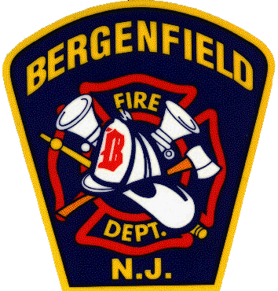 | Bergenfield Fire Department  198 North Washington Ave.  Bergenfield, N.J. 07621  (201) 387-4000 ext. 4073

4/30/2026
OPRA Request; Fire Damage Report

The following is a list of addresses within the borough that have suffered fire damage between January 1, 2026 & March 31, 2026.

2026-000059: 166 W. Main St.
2026-000110: 107 Roosevelt Ave.
2026-000205: 307 E. Johnson Ave.
2026-000226: 66 Pleasant Ave.

