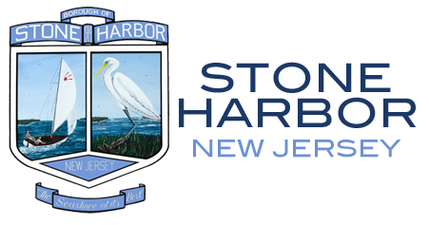

REQUEST FOR GOVERNMENT RECORDS
(N.J.S.A. 47:1A – 1, et seq.)

GOVERNMENT RECORDS REQUEST RESPONSE

TO: Peter Tapiavala

DATE: January 12, 2026

The Borough of Stone Harbor received your Open Public Records Act (OPRA) request on January 6, 2026, seeking access to the following:

Please see response below to records requested from 07/01/2025 – 12/31/2025:
- Tax Delinquent List – Provided without Redactions
- Open Property Liens – No Records Responsive
- Water/ Utility Shut Off – No Records Responsive
- Code Violation – No Records Responsive
- Vacant List/ Abandoned – Provided without Redactions
- Condemned Properties – No Records Responsive
- Fire Damage List – Provided without Redactions

This response is provided within the seven-business-day deadline required by OPRA. If you believe your request has been improperly denied, you have the right to challenge this decision by filing a complaint with the Government Records Council (GRC) at P.O. Box 819, Trenton, NJ 08625, by email at grc@dca.state.nj.us, or by calling 866-850-0511. Additional information is available at www.state.nj.us/grc. Alternatively, you may institute a proceeding in the Superior Court of New Jersey.

Questions regarding Superior Court filings should be directed to the Court Clerk in Cape May County.

Sincerely,

Jeanne M. Parkinson

Jeanne M. Parkinson, RMC
Borough Clerk

