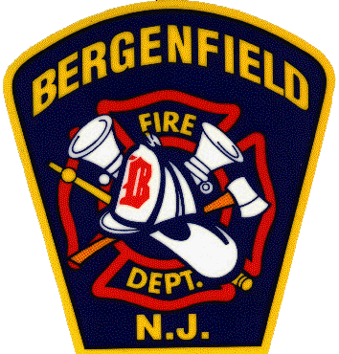 | Bergenfield Fire Department  198 North Washington Ave.  Bergenfield, N.J. 07621  (201) 387-4000 ext. 4073

1/11/2026
OPRA Request
Fire Damage List 7/1/2025 – 12/31/2025

This is a list of property addresses that have had Fire Department response from 7/1/2025 – 12/31/2025;

-7/23/2025: 15 W. Johnson Ave.
-7/29/2025: 168 W. Central Ave.
-8/4/2025: 238 E. Johnson Ave.
-8/16/2025: 34 Armour Pl.
-8/31/2025: 154 E. Johnson Ave.
-9/5/2025: 11 Carnation St.
-9/13/2025: 23 N. Taylor St.
-10/10/2025: 88 N. First St.
-10/14/2025: 240 N. Prospect Ave.
-10/28/2025: 60 River Edge Rd.

Respectfully,

Ryan J. Zadrozna
Chief of Department
Bergenfield Fire Department

