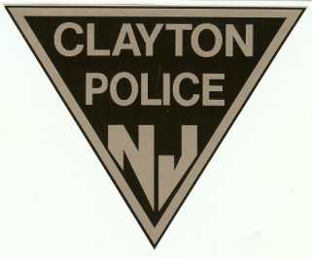
Clayton Police Department
125 N. Delsea Drive, Clayton, New Jersey 08312
Telephone (856) 881-2301
Fax (856) 881-5859
Chief Andrew Davis

March 1, 2022

Via email only (opra+request-29545-89ff529a@requests.opramachine.com)
Rise Against Hate

Re: Open Public Records Act/Common Law Records Request

Dear Sir/Madam:

The Borough of Clayton Records Custodian received your request for records pursuant to the Open Public Records Act (OPRA) and the New Jersey common law right of access, dated February 16, 2022, on February 17, 2022, and forwarded it to the Police Records Custodian on that day for response. Accordingly, the initial seven (7) business day deadline to respond to your request under OPRA is March 1, 2022. This response is being provided on the seventh business day after receipt of your request.

Your records request was as follows:

A search of our available records has identified the enclosed records as responsive to your request:

Complaint-Summons (CDR-1) 01/01/22 to 01/31/22 (103 pages)

Copies of the identified records are enclosed. Please note that, after consultation with the Borough Solicitor, these records have been redacted as follows:

Privacy/Personal/Juvenile Information. Part(s) of the identified record(s) containing personal and/or juvenile information for which identified persons have a reasonable expectation of privacy have been redacted. N.J.S.A. 47:1A-1; Executive Order No. 21 (McGreevey 2002); Paff v. Ocean County Prosecutor’s Office, 235 N.J. 1 (2018); Brennan v. Bergen County Prosecutor’s Office, 233 N.J. 330 (2018); In the Matter of the New Jersey State Fireman’s Association, 230 N.J. 258 (2017); Burnett v. County of Bergen, 198 N.J. 408 (2009); North Jersey Media Group v. Township of Nutley, slip op., Docket No. A-3483-14T3 (App. Div. September 30, 2016); Nelson v. N.J. Department of Law & Public Safety, No. 2013-124 (GRC 2014); Merino v. Borough of Ho-Ho-Kus, No. 2003-110 (GRC 2004).

If your request for access to a government record has been denied or unfilled within the seven (7) business days required by law, you have a right to challenge the decision by the Borough of Clayton to deny access. At your option, you may either institute a proceeding in the Superior Court of New Jersey or file a complaint with the Government Records Council (GRC) by completing the Denial of Access Complaint Form. You may contact the GRC by toll-free telephone at 866-850-0511, by mail at P.O. Box 819, Trenton, NJ, 08625, by e-mail at grc@dca.state.nj.us, or at their web site at www.state.nj.us/grc. The GRC can also answer other questions about the law. All questions regarding complaints filed in Superior Court should be directed to the Court Clerk in your County.

Very truly yours,

Andrew Davis
Chief of Police
Borough of Clayton

