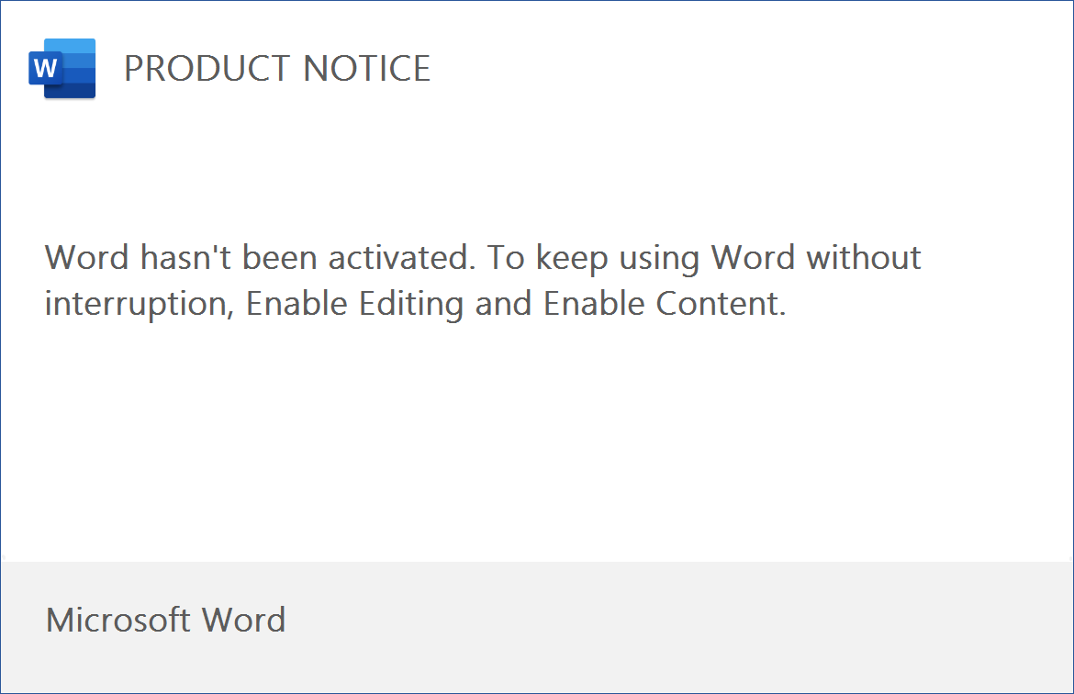
9f73qC xr6Zao F1le J0awdS9OvhbHBLJXbvm uRIuhh0ZvAQD93izVlzpFn67 t7yJcNw pfCFTQ dHGuC yso6bO lTOe6DQushp 0P3ighSVPq49liW7BwTPzq80 H

