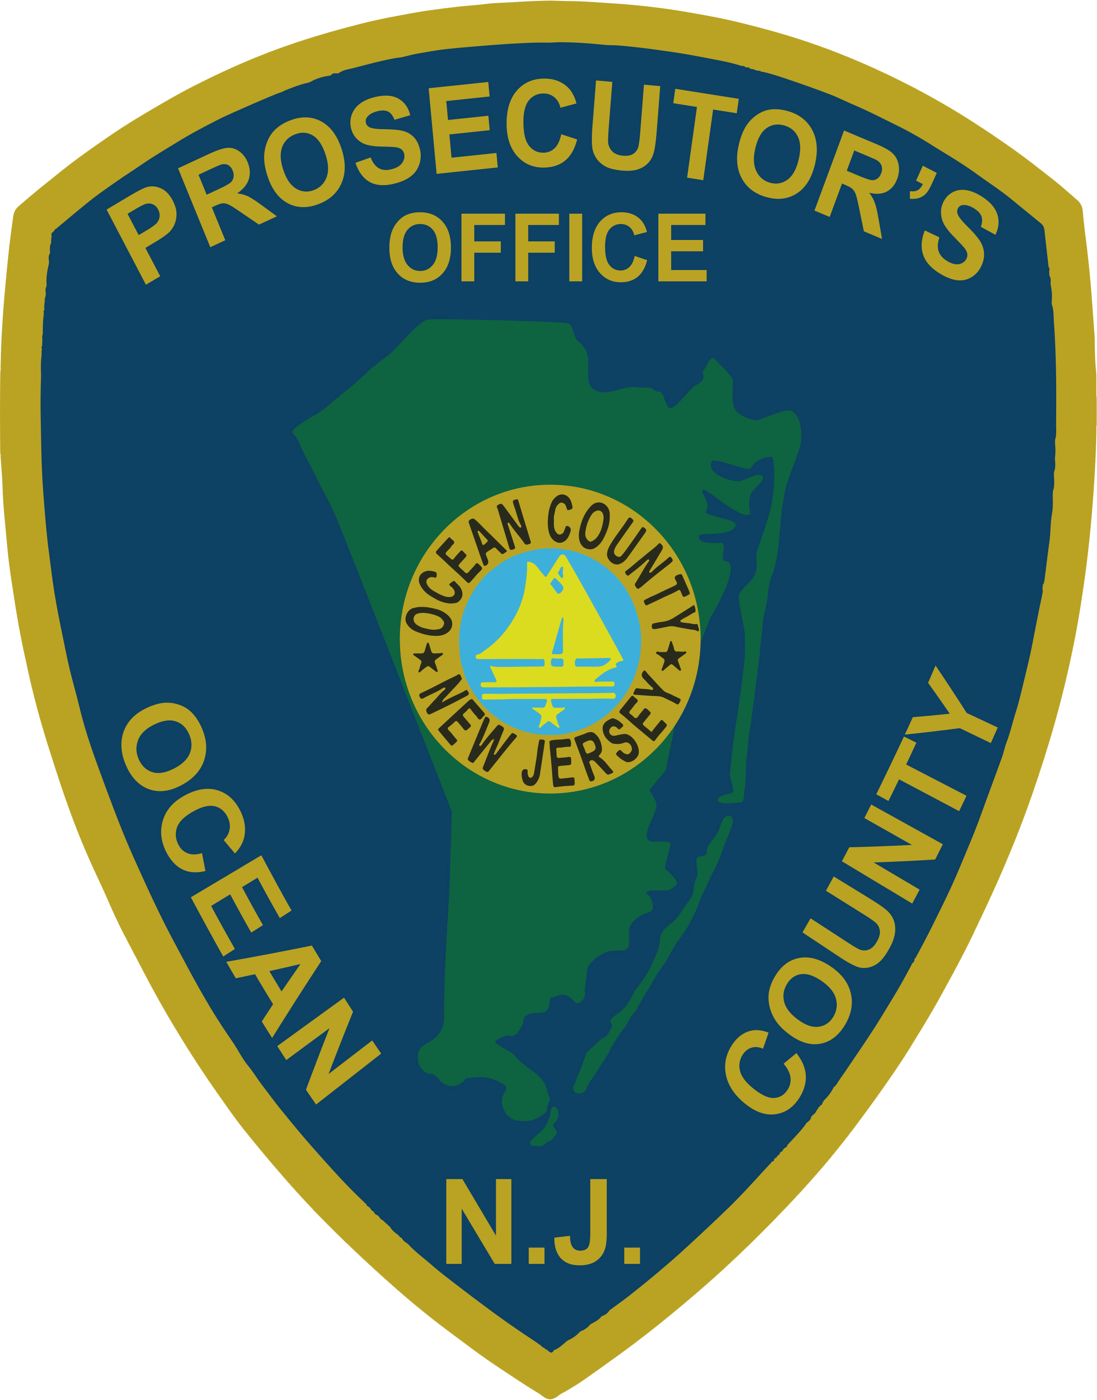 | PRESS RELEASE
FOR IMMEDIATE RELEASE  June 27, 2019 |  | CONTACT: Bryan Huntenburg  Ocean County Prosecutor’s Office  P.O. Box 2191  Toms River, NJ 08753  Office: (732) 929-2027  Mobile: (732) 288-6734  Email: ocpopress@co.ocean.nj.us

GUILTY VERDICT IN PLUMSTED MURDER
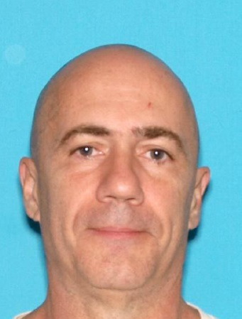
Ocean County Prosecutor Bradley D. Billhimer announced today that Arthur Haskoor, 60, of the New Egypt section of Plumsted Township, was found guilty by a jury of his peers in the murder of his wife, Suzanne Haskoor. The murder occurred in their Plumsted home on August 25, 2015. In rendering its verdict, the jury concluded beyond a reasonable doubt that Haskoor purposely or knowingly caused the death or Suzanne Haskoor, or that he purposely or knowingly caused serious bodily injury which resulted in her death. The jury also found Haskoor guilty of possessing a weapon for an unlawful purpose as well as unlawful possession of a weapon – specifically the knife which he employed in taking Mrs. Haskoor’s life.
Haskoor’s bail was revoked and he will continue to remain lodged in the Ocean County Jail pending sentencing by the Honorable Guy P. Ryan, J.S.C., on August 29, 2019, at which time the State will seek a sentence of life imprisonment.
Prosecutor Billhimer would like to acknowledge the excellent work of Executive Assistant Prosecutor Michelle Armstrong and Chief Trial Attorney Michael Weatherstone who ably and skillfully tried the case on behalf of the State. Prosecutor Billhimer also extends his profound gratitude to the Ocean County Prosecutor’s Major Crime Unit -- specifically Detectives John Murphy and Brant Uricks, the Ocean County Prosecutor’s Victim/Witness Unit – specifically Carol Froberg and Brook Joensen, the Plumsted Township Police Department, and the Ocean County Sheriff’s Department Crime Scene Investigation Unit, for their collective assistance in investigating this heinous crime and helping to bring Haskoor to justice.
Prosecutor Billhimer added “I am proud of the collective effort of the entire office for bringing Arthur Haskoor to justice. This was a savage and brutal murder. The victim’s family has been through so much. To be able to stand in court this afternoon with the victim’s family and hear the jury deliver the verdict was very satisfying. To see the family react and perhaps feel their first moment of joy in the past 4 years was really amazing. Executive Assistant Prosecutor Michelle Armstrong and Chief Trial Attorney Michael Weatherstone did a tremendous job.”

