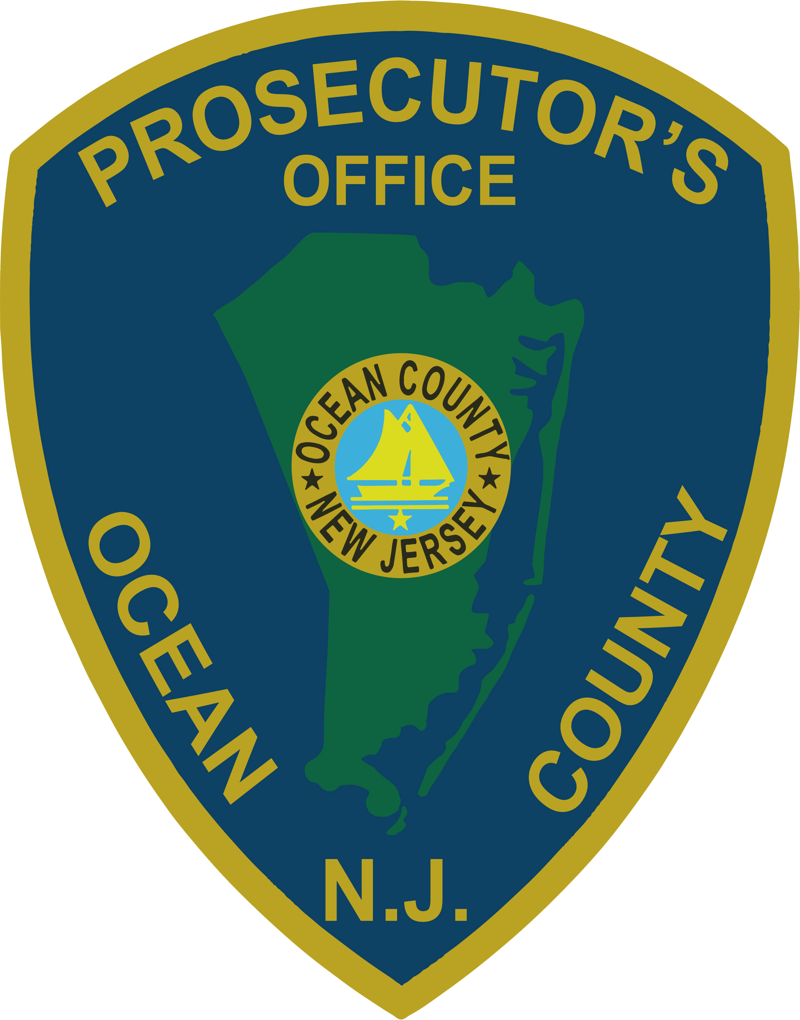 | PRESS RELEASE
FOR IMMEDIATE RELEASE  July 24, 2019 |  | CONTACT: Bryan Huntenburg  Ocean County Prosecutor’s Office  P.O. Box 2191  Toms River, NJ 08753  Office: (732) 929-2027  Mobile: (732) 288-6734  Email: ocpopress@co.ocean.nj.us

TWENTY-FOUR COUNT INDICTMENT IN STRICT LIABILITY
DRUG-INDUCED DEATH

Ocean County Prosecutor Bradley D. Billhimer has announced the Indictment of several individuals in connection with a Strict Liability Drug-Induced Death which occurred on January 12, 2019. On July 23, 2019, a Grand Jury sitting in Ocean County indicted Curtis M. Geathers, Michael M. Tiedemann, and Tiffany R. Coger with distributing a combination drug packaged in wax folds containing Heroin and Fentanyl to an individual between January 9th and 10th of, 2019, the ingestion of which resulted in that person’s death.
This Indictment is the result of a collaborative investigation conducted by multiple law enforcement agencies in Ocean County, including the Ocean County Prosecutor’s Office Major Crime Unit, Ocean County Prosecutor’s Office Narcotics Strike Force, Point Pleasant Borough Police Department, Seaside Heights Police Department, Toms River Township Police Department, Toms River Police Department’s Special Enforcement Team and the Ocean County Sheriff’s Department’s Crime Scene Investigation Unit. The investigation revealed that Geathers distributed a quantity of wax folds containing a combination of Heroin and Fentanyl to Coger and Tiedemann between the dates of January 5, 2019 and January 9, 2019. On January 9, 2019, Tiedemann distributed a quantity of the wax folds that he had bought from Geathers to the victim. On the morning of January 10, 2019, the victim’s family discovered the victim unresponsive inside the home and contacted the police. The victim was pronounced dead on January 12, 2019. It was determined through the investigation that the victim died as a result of ingesting Herion and Fentanyl.

The Indictment reads as follows:
Curtis M. Geathers, 33, of Barnegat, was charged with one (1) count of Strict Liability Drug Induced Death in violation of N.J.S.A. 2C:35-5 and N.J.S.A. 2C:35-9a; two (2) counts of Distribution of Heroin in an amount less than one-half ounce in violation of N.J.S.A. 2C:35-5a(1) and N.J.S.A. 2C:35-5b(3); two (2) counts of Possession with Intent to Distribute Heroin in an amount less than one-half ounce in violation of N.J.S.A. 2C:35-5a(1) and N.J.S.A. 2C:35-5b(3); two (2) counts of Possession of Heroin in violation of amount less than one ounce in violation of N.J.S.A. 2C:35-5a(1) and N.J.S.A. 2C:35-5b(5); three (3) counts of Possession with Intent to Distribute Fentanyl in an amount less than one ounce in violation of N.J.S.A. 2C:35-5a(1) and N.J.S.A. 2C:35-5b(5); three (3) counts of Possession of Fentanyl in violation of N.J.S.A. 2C:35-10a(1); and one (1) count of Possession Methamphetamine in violation of N.J.S.A. 2C:35-10a(1). Geathers is presently lodged in the Ocean County Jail pending a detention hearing.

Michael M. Tiedemann, 45, of Toms River, is charged with one (1) count of Strict Liability Drug Induced Death in violation of N.J.S.A. 2C:35-5 and N.J.S.A. 2C:35-9a; one (1) count of Distribution of Heroin in an amount less than one-half ounce in violation of N.J.S.A. 2C:35-5a(1) and N.J.S.A. 2C:35-5b(3); two (2) counts of Possession with Intent to Distribute Heroin in an amount less than one-half ounce in violation of N.J.S.A. 2C:35-5a(1) and N.J.S.A. 2C:35-5b(3); two (2) counts of Possession of Heroin in violation of N.J.S.A. 2C:35-10a(1); one (1) count of Distribution of Fentanyl in an amount less than one ounce in violation of N.J.S.A. 2C:35-5a(1) and N.J.S.A. 2C:35-5b(5); two (2) counts of Possession with Intent to Distribute Fentanyl in an amount less than one ounce in violation of N.J.S.A. 2C:35-5a(1) and N.J.S.A. 2C:35-5b(5); two (2) counts of Possession of Fentanyl in violation of N.J.S.A. 2C:35-10a(1); one (1) count of Possession with Intent to Distribute Cocaine in an amount less than one-half ounce in violation of N.J.S.A. 2C:35-5a(1) and N.J.S.A. 2C:35-5b(3); and one (1) count of Possession of Cocaine in violation of N.J.S.A. 2C:35-10a(1). An Indictment Warrant has been issued for Tiedemann’s arrest.

Tiffany R. Coger, 35, of Seaside Heights, is charged with one (1) count of Strict Liability Drug Induced Death in violation of N.J.S.A. 2C:35-5 and N.J.S.A. 2C:35-9a; two (2) counts of Distribution of Heroin in an amount less than one-half ounce in violation of N.J.S.A. 2C:35-5a(1) and N.J.S.A. 2C:35-5b(3); two (2) counts of Possession with Intent to Distribute Heroin in an amount less than one-half ounce in violation of N.J.S.A. 2C:35-5a(1) and N.J.S.A. 2C:35-5b(3); two (2) counts of Possession of Heroin in violation of N.J.S.A. 2C:35-10a(1); two (2) counts of Distribution of Fentanyl in an amount less than one ounce in violation of N.J.S.A. 2C:35-5a(1) and N.J.S.A. 2C:35-5b(5); two (2) counts of Possession with Intent to Distribute Fentanyl in an amount less than one ounce in violation of N.J.S.A. 2C:35-5a(1) and N.J.S.A. 2C:35-5b(5); two (2) counts of Possession of Fentanyl in violation of N.J.S.A. 2C:35-10a(1); and one (1) count of Possession of Cocaine in violation of N.J.S.A. 2C:35-10a(1). An Indictment Warrant has been issued for Coger’s arrest.
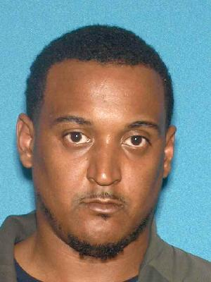
Though not alleged to be criminally responsible in the victim’s death, a fourth individual, Darnell D. Williams, 36, of Jackson, has been charged in this investigation with one (1) count of Distribution of Cocaine in violation of N.J.S.A. 2C:35-5a(1) and N.J.S.A. 2C:35-5b(3); one (1) count of Possession with Intent to Distribute Cocaine in an amount less than one-half ounce in violation of N.J.S.A. 2C:35-5a(1) and N.J.S.A. 2C:35-5b(3); and one (1) count of Possession of Cocaine in violation of N.J.S.A. 2C:35-10a(1). Williams is already lodged in the Ocean County Jail on other charges.

Prosecutor Billhimer would like to acknowledge the collective efforts of all law enforcement personnel involved in the extensive investigation of this tragic and unnecessary death. “This was a collaborative effort on the part of my office and many of our local police departments. We are all committed to sharing our intelligence to make sure we put these drug dealers on notice; Ocean County is not the place to pedal your illegal and dangerous narcotics” Prosecutor Billhimer said.
The media and public are reminded that all defendants are presumed innocent until proven guilty in a court of law beyond a reasonable doubt.

