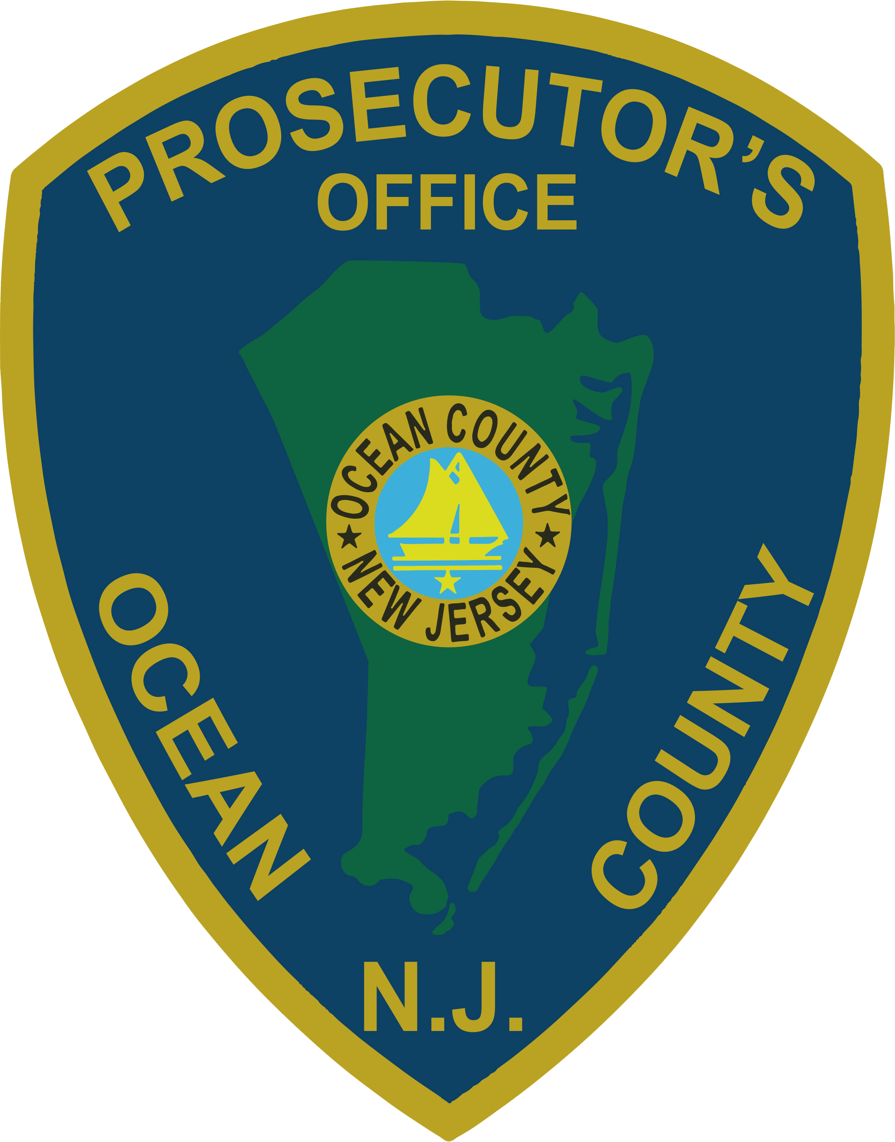 | PRESS RELEASE
FOR IMMEDIATE RELEASE  June 28, 2019 |  | CONTACT: Bryan Huntenburg  Ocean County Prosecutor’s Office  P.O. Box 2191  Toms River, NJ 08753  Office: (732) 929-2027  Mobile: (732) 288-6734  Email: ocpopress@co.ocean.nj.us

PROSECUTOR ANNOUNCES DRUG DISTRIBUTION ARRESTS

Ocean County Prosecutor Bradley D. Billhimer announced today the culmination of a two month multi-agency investigation into drug activity in the Ocean County area. On Wednesday, June 26, 2019 Ocean County Prosecutors Office Narcotics Strike Force Detectives executed no-knock search warrants at residences in Toms River, Pine Beach and Point Pleasant Borough and Lakewood. As a result of the search warrants, Narcotics Strike Force Detectives seized nearly two ounces of crack cocaine, quantities of heroin, marijuana and Oxycodone pills. Narcotics Strike Force Detectives also seized approximately $50,000.00 in cash and drug paraphernalia associated with the packaging and distribution of narcotics. The Asset Forfeiture Unit of the Narcotics Strike Force identified a bank account with an additional $17,942.00. That account was also seized pending forfeiture proceedings. Arrested were:


Kadeem Evans, age 27, of Toms River was charged with Distribution of Cocaine Less Than One Half Ounce in violation of N.J.S.A. 2C:35-5b(3), Possession of Cocaine in a Quantity of Less Than One Half Ounce with the Intent to Distribute in violation of N.J.S.A. 2C:35-5b(3), Possession of Crack Cocaine Less Than One Half Ounce with the Intent to Distribute in violation of N.J.S.A. 2C: 35-5b(3), Possession of Oxycodone in a Quantity of Less Than One Half Ounce with the Intent to Distribute in violation of N.J.S.A. 2C:35-5b(3), Possession of Cocaine in violation of N.J.S.A. 2C35-10a(1), Possession of Oxycodone in violation of N.J.S.A. 2C: 35-10a(1), Possession of Crack Cocaine in violation of N.J.S.A. 2C35-10a(1), Financial Facilitation of Criminal Activity in violation of N.J.S.A. 2C:21-25a and Possession of Drug Paraphernalia in violation of N.J.S.A. 2C:36-2. Evans is lodged in the Ocean County Jail pending a detention hearing.

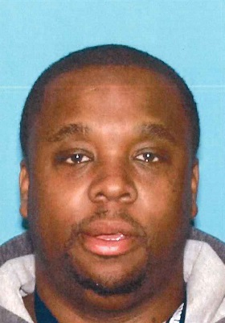
Michael Trotman, age 34, of Pine Beach was charged with Distribution of Cocaine Less than One half Ounce in violation of N.J.S.A. 2C35-5b(2), Possession of Cocaine in a Quantity of Over One Half Ounce with the Intent to Distribute in violation of N.J.S.A. 2C:35-5b(2), Possession of Cocaine in violation of N.J.S.A. 2C:35-10, Financial Facilitation of Criminal Activity in violation of N.J.S.A. 2C: 21-25a, Possession of Marijuana with the Intent to Distribute in violation of N.J.S.A. 2C: 35-5b(12), Possession of Marijuana in violation of N.J.S.A. 2C:35-10a(4) and Possession of Drug Paraphernalia in violation of N.J.S.A. 2C36-2. Trotman is lodged in the Ocean County Jail pending a detention hearing.

Prosecutor Billhimer would like to acknowledge the collaborative efforts of the following agencies in this investigation, Ocean County Prosecutor’s Office Narcotics Strike Force, Ocean County Prosecutor’s Office Asset Forfeiture Unit, Toms River Police Department Emergency Services Unit, Toms River Police Department K-9 Unit, Toms River Police Department Special Enforcement Team, Ocean County Sheriff’s Department K-9 Unit, Ocean County Regional SWAT Team, Point Pleasant Borough Police Department and Detective Bureau, Pine Beach Police Department, Barnegat Township Police and Crime Reduction Unit, New Jersey State Police Gang and Organized Crime Unit and the Lakewood Police and Street Crimes Unit.

“We will continue our aggressive approach to investigating and arresting those individuals that pedal illegal narcotics in Ocean County. I can’t stress enough how important it is for all of our law enforcement partners to collaborate and share intelligence when it comes to investigating these drug dealers” Prosecutor Billhimer stated.

The public and media are reminded that all defendants are innocent until proven guilty in a court of law.

Follow the Office of the Ocean County Prosecutor online on Facebook, Twitter and Instagram.
The social media links provided are for reference only.
OCPO does not endorse any non-governmental websites, companies or applications.
For additional information, visit our Facebook Page at https://www.facebook.com/OCPONJ/

