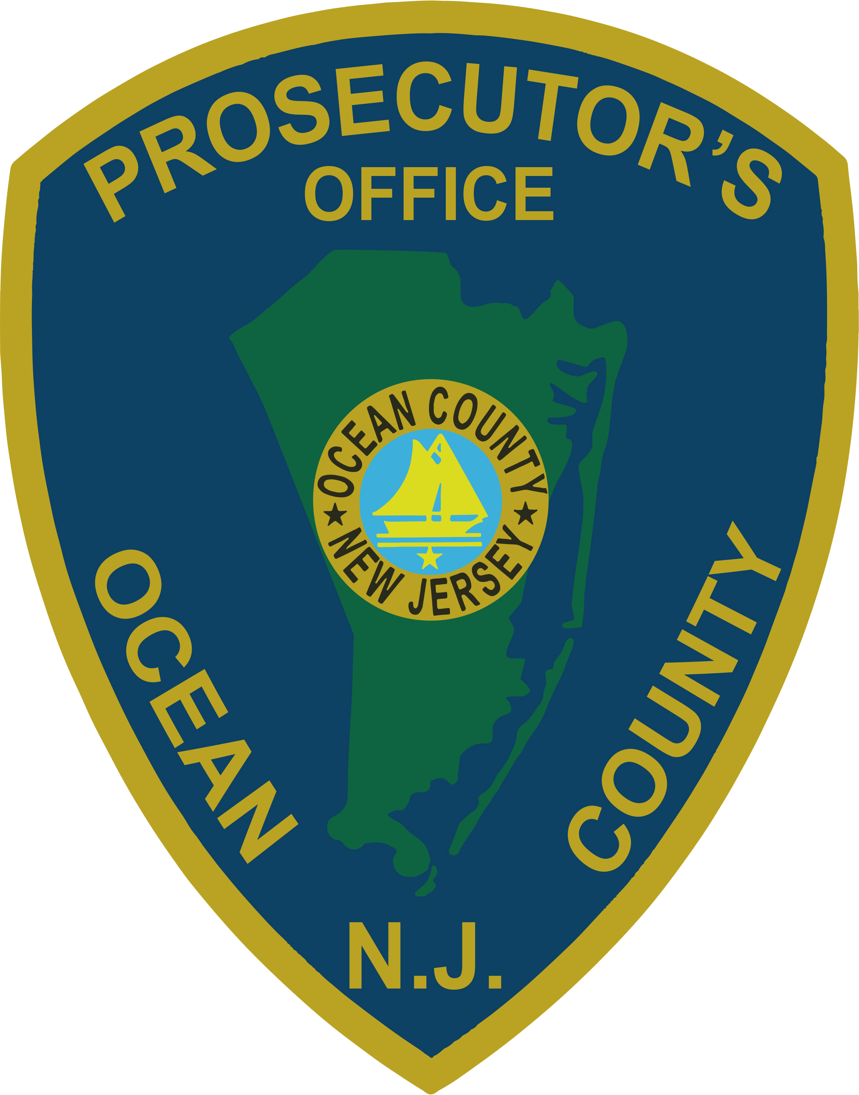 | PRESS RELEASE
FOR IMMEDIATE RELEASE  July 25, 2019 |  | CONTACT: Bryan Huntenburg  Ocean County Prosecutor’s Office  P.O. Box 2191  Toms River, NJ 08753  Office: (732) 929-2027  Mobile: (732) 288-6734  Email: ocpopress@co.ocean.nj.us

OCEAN COUNTY PROSECUTOR & BOROUGH OF SOUTH TOMS RIVER TO HOST “STOPPING DOMESTIC VIOLENCE,”
AN INFORMATIONAL SESSION REGARDING DOMESTIC VIOLENCE

Ocean County Prosecutor Bradley D. Billhimer and the Borough of South Toms River will be presenting a FREE informational session regarding Domestic Violence at the Second Baptist Church on Railroad Ave, South Toms River, on Thursday, August 1, 2019, from 6:00 p.m. until 8:00 p.m. “Stopping Domestic Violence” will address the cycle of Domestic Violence and the effects it has on the whole family. Prosecutor Billhimer will be joined by representatives from the Ocean County Prosecutor’s Office Domestic Violence Unit and Victim Witness Advocacy Unit, the Borough of South Toms River, Providence House and South Toms River Deputy Mayor Rob Taylor. Assistance and guidance will be provided for victims of domestic violence. Admission is free and everyone is welcome to attend.



