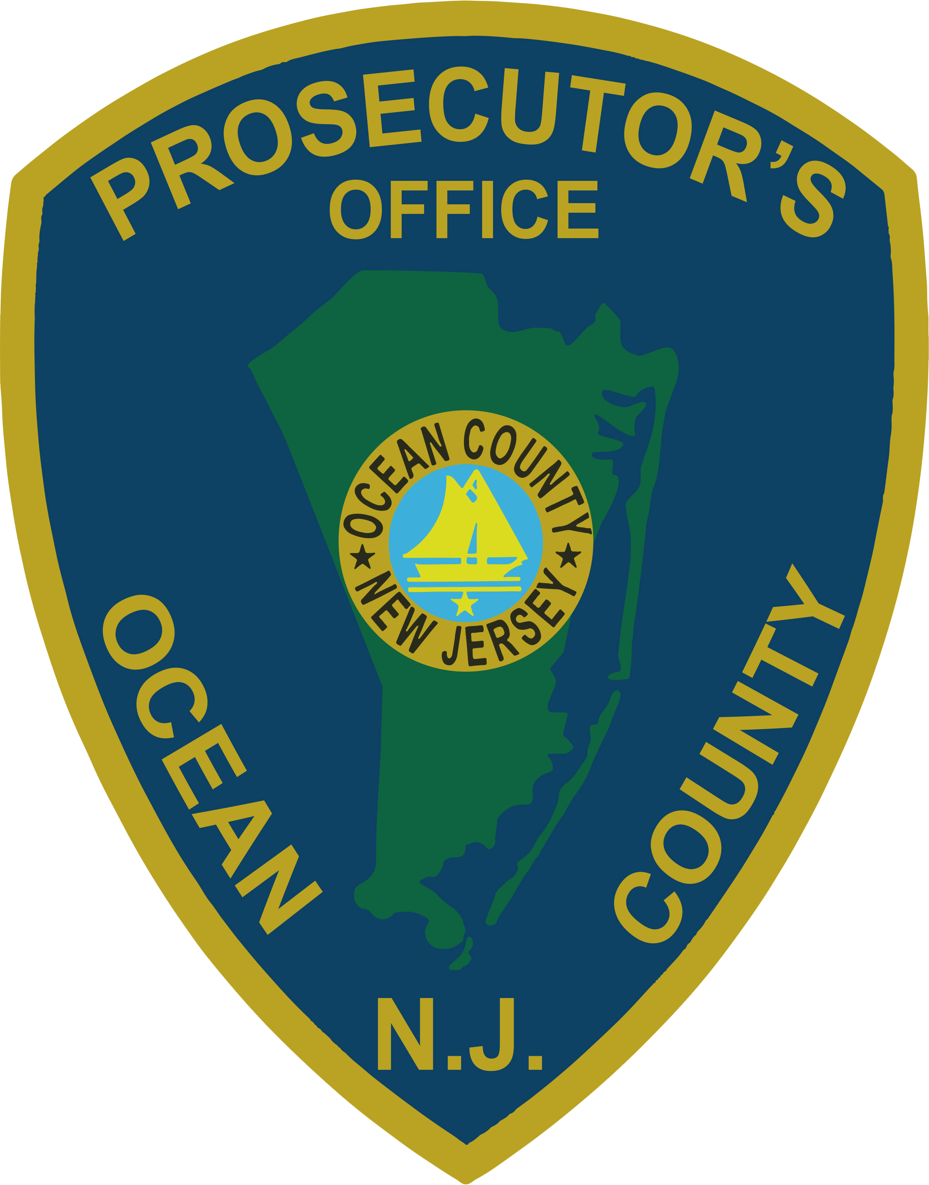 | PRESS RELEASE
FOR IMMEDIATE RELEASE  June 18, 2019 |  | CONTACT: Bryan Huntenburg  Ocean County Prosecutor’s Office  P.O. Box 2191  Toms River, NJ 08753  Office: (732) 929-2027  Mobile: (732) 288-6734  Email: ocpopress@co.ocean.nj.us

COUNTY PROSECUTORS ASSOCIATION OF NEW JERSEY, INC.

ANNUAL SCHOLARSHIPS

Ocean County Prosecutor Bradley D. Billhimer announced that the County Prosecutors Association of New Jersey annually awards three scholarships to law school students and one scholarship to college or graduate students. Each scholarship is a one-year grant in the amount of $3,500.00 paid directly to the recipient. Scholarship recipients from previous years are ineligible. The County Prosecutors Association of New Jersey Inc. announces the availability of the following scholarships:

The Oscar W. Rittenhouse Memorial Scholarship
The Andrew K. Ruotolo Jr. Memorial Scholarship
The Harris Y. Cotton Memorial Scholarship
The John H. Stamler Memorial Scholarship

To be eligible for the Oscar W. Rittenhouse Memorial Scholarship, an applicant must be a New Jersey resident accepted for admission into a law school. The applicant must have an interest in pursuing a career as a prosecutor. The applicant must also demonstrate financial need.

To be eligible for the Andrew K. Ruotolo, Jr. Memorial Scholarship, an applicant must be a New Jersey resident accepted for admission to a law school or a graduate school. The applicant must exhibit an interest in, and commitment to, enhancing the rights and well-being of children through child advocacy programs. The applicant must also demonstrate financial need.

To be eligible for the Harris Y. Cotton Memorial Scholarship, an applicant must be a New Jersey resident accepted for admission to a law school. The applicant must have an interest in pursuing a career as a prosecutor with an emphasis in Domestic Violence or Hate Crime prosecutions. The applicant must also demonstrate financial need.

To be eligible for the John H. Stamler Memorial Scholarship, an applicant must be a New Jersey resident and sworn law enforcement officer seeking educational advancement on a college or graduate level to improve his or her effectiveness as a law enforcement officer. The applicant must also demonstrate financial need.

Deadline for submission of applications is September 3, 2019. Applicants will be notified of the Committee’s decision in October 2018.

You can apply online at:
https://ftp.mcponj.org/?ShareToken=25B48082F6B7A324BF8A94E6C4339A431818A926

Follow the Office of the Ocean County Prosecutor online on Facebook, Twitter and Instagram.
The social media links provided are for reference only.
OCPO does not endorse any non-governmental websites, companies or applications.
For additional information, visit our Facebook Page at https://www.facebook.com/OCPONJ/

