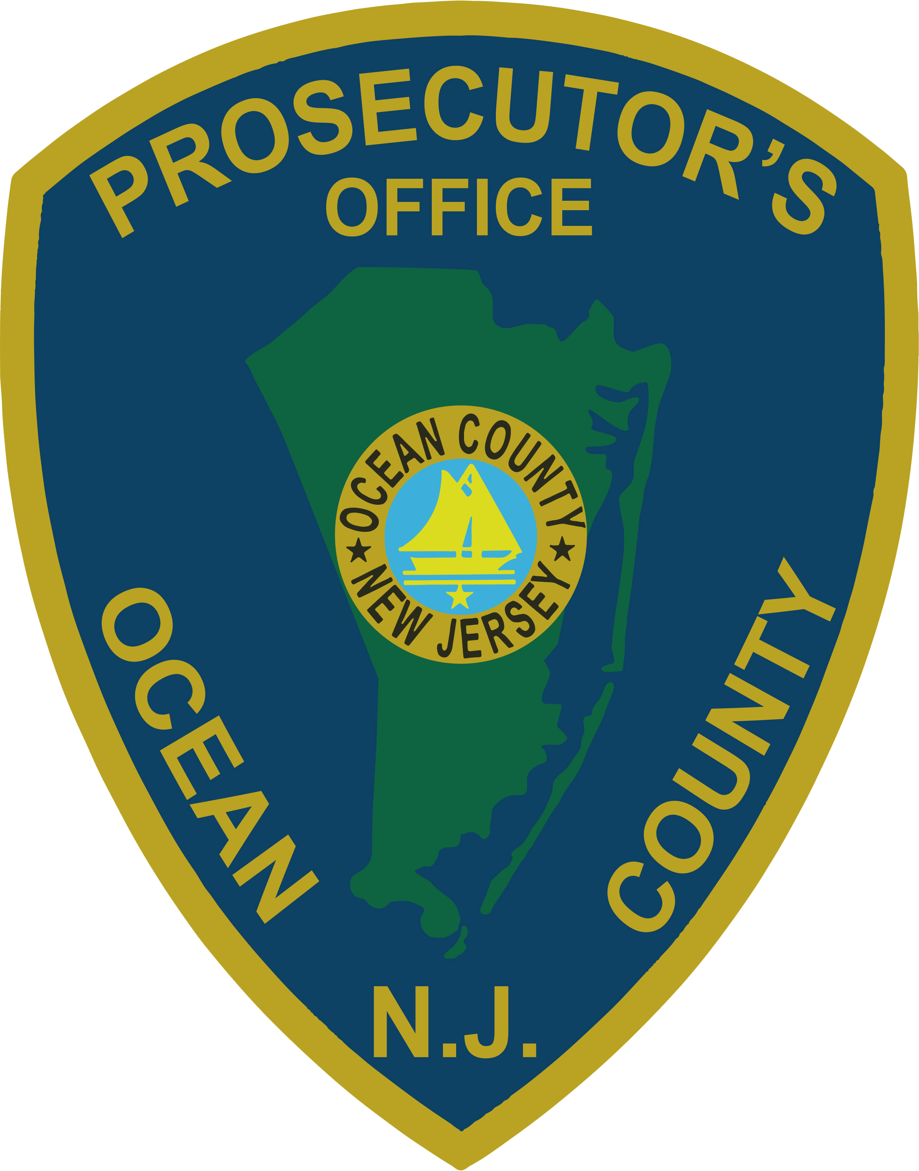 | PRESS RELEASE
FOR IMMEDIATE RELEASE  June 10, 2019 |  | CONTACT: Bryan Huntenburg  Ocean County Prosecutor’s Office  P.O. Box 2191  Toms River, NJ 08753  Office: (732) 929-2027  Mobile: (732) 288-6734  Email: ocpopress@co.ocean.nj.us

LEADER OF NARCOTICS TRAFFICKING NETWORK
SENTENCED TO LIFE IN PRISON

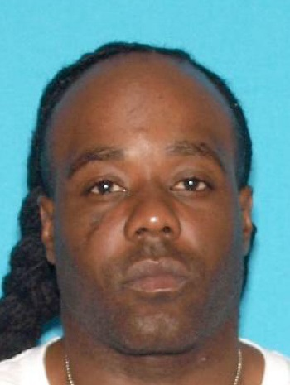
Ocean County Prosecutor Bradley D. Billhimer announced that on Friday, June 7, 2019, Daryel Rawls, 38, was sentenced by the Honorable Rochelle Gizinski, J.S.C., to a term of life imprisonment with a mandatory stipulation of parole ineligibility for 25 years for being the Leader of a Narcotics Trafficking Network in violation of N.J.S.A. 2C:35-3. Additionally, Judge Gizinski imposed a consecutive 10 year term with a 5 year parole disqualifier for Conspiracy to Possess Heroin with Intent to Distribute in violation of N.J.S.A. 2C:35-5a and N.J.S.A. 2C:5-2, Possession with Intent to Distribute Heroin in violation of N.J.S.A. 2C:35-5a, and Possession with Intent to Distribute Cocaine in violation of N.J.S.A. 2C:35-5a. The net effect of this sentence is that Rawls must do at least 30 years in state prison before he may even be considered for parole.

Rawls was the target of an extensive wiretap investigation named “Operation Baked Zito.” Rawls was also known as “Z” or “Zito.” Thousands of intercepted calls led to 25 individuals being charged, including Rawls. At the time of his arrest, Rawls was in possession of over 1100 wax folds of heroin, as well as a clear bag of cocaine weighing 26 grams.

Rawls failed to appear for his trial and was convicted by a jury of his peers, in absentia, on March 22, 2017. Rawls remained a fugitive until he was apprehended on drug charges in Milford, Connecticut on December 12, 2018. After returning to Ocean County, he filed a motion for a new trial; this motion was denied by Judge Gizinski, who then proceeded to sentence Rawls.

Prosecutor Billhimer would like to thank Supervising Assistant Prosecutor Michael Abatemarco and Senior Assistant Prosecutor Robert Cassidy who tried the case on behalf of the State, as well as the members of the Ocean County Prosecutor’s Office Narcotics Strike Force, the New Jersey State Police, and the Ocean County Sheriff’s Department for their collective assistance in bringing Rawls to justice.

Follow the Office of the Ocean County Prosecutor online on Facebook, Twitter, and Instagram.

