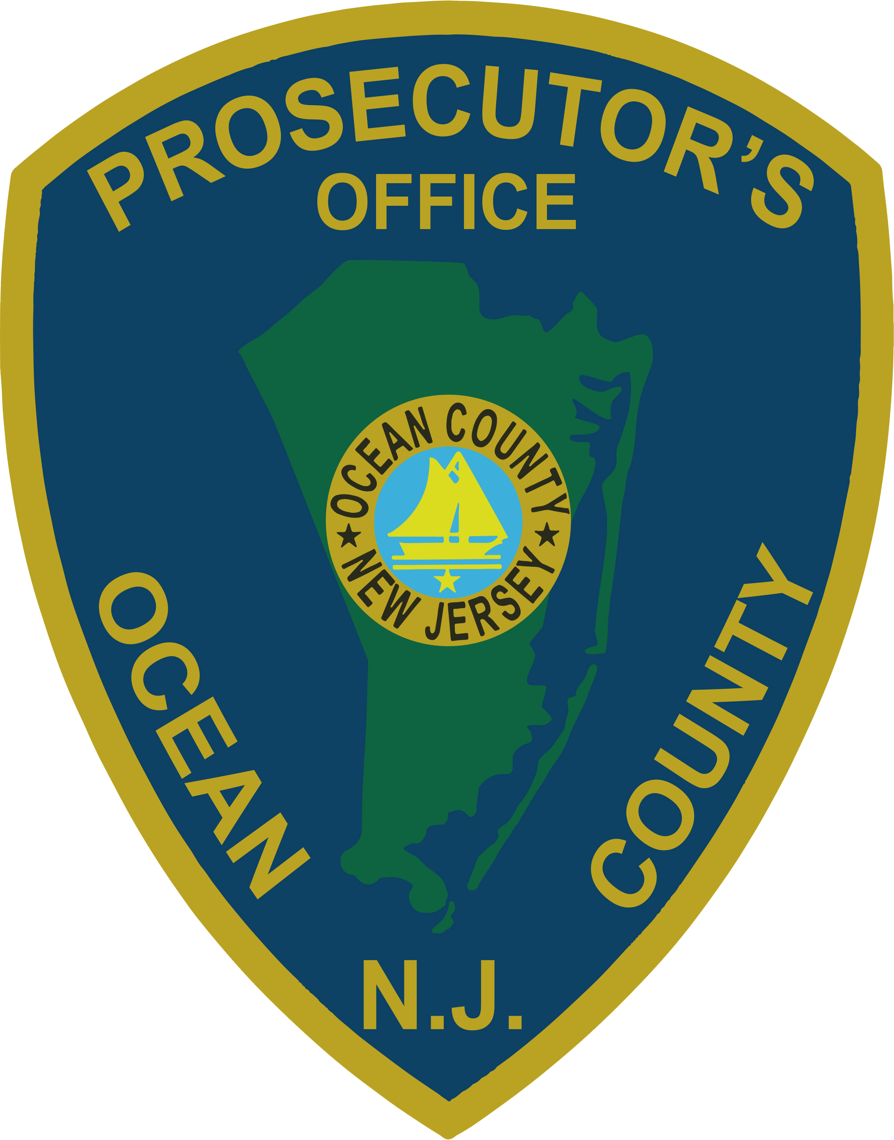 | PRESS RELEASE
FOR IMMEDIATE RELEASE  August 7, 2019 |  | CONTACT: Bryan Huntenburg  Ocean County Prosecutor’s Office  P.O. Box 2191  Toms River, NJ 08753  Office: (732) 929-2027 Mobile: (732) 288-6734  Email: ocpopress@co.ocean.nj.us
ARRESTS IN LAKEWOOD/BARNEGAT HEROIN MANUFACTURING AND FIREARMS POSSESSION
Ocean County Prosecutor Bradley D. Billhimer and Lakewood Township Police Chief Gregory Meyer have announced the culmination of a three-month, multi-agency cooperative investigation into the distribution of heroin in the Ocean County area. This investigation identified three separate locations in Lakewood and one location in Barnegat as being utilized to store, package and dispense quantities of heroin as part of an extensive drug trafficking scheme. On August 6, 2019, Detectives from the Ocean County Prosecutor’s Office Narcotics Strike Force, the Ocean County Prosecutor’s Office Regional SWAT Team, and the Ocean County Prosecutor’s Office Asset Forfeiture Unit, along with Officers and Detectives from the Lakewood Township Police Department, the Toms River Township Police Department, the Barnegat Township Police Department, the Stafford Township Police Department, the Ocean County Sheriff’s Department, and the Monmouth/Ocean County DEA HIDTA Group, executed no-knock search warrants at these particular locations. As a result, evidence associated with the operating and maintaining a Controlled Dangerous Substance Production Facility was seized, along with approximately 1500 individual dosage units of heroin, various quantities of marijuana, $1,200 in cash, and three handguns. The following individuals were arrested and charged:

Tony Olden, 33, of Lakewood, was charged with one Count of Maintaining a Controlled Dangerous Substance Production/Manufacturing Facility in violation of N.J.S.A. 2C:35-4; one Count of Possession of Over One-Half Ounce of Heroin with Intent to Distribute in violation of N.J.S.A. 2C:35-5b(2); one Count of Possession of Heroin with Intent to Distribute within 500 feet of a Public Park in violation of N.J.S.A. 2C:35-7.1a; Possession of Heroin in violation of N.J.S.A. 2C:35-10a; two counts of Possession of a Weapon for an Unlawful Purpose in violation of N.J.S.A. 2C:39-4a(1); two counts of Possession of a Handgun While Committing a Controlled Dangerous Substance Offense in violation of N.J.S.A. 2C:39-4.1a; two counts of being a Certain Person Not to Possess a Weapon in violation of N.J.S.A. 2C:39-7b(1); two counts of Unlawful Possession of a Weapon in violation of N.J.S.A. 2C:39-5b(1); one Count of Possession of a Defaced Firearm in violation of N.J.S.A. 2C:39-3d; and Possession of Prohibited Ammunition in violation of N.J.S.A. 2C:39-3f(1). Olden is lodged in the Ocean County Jail pending a detention hearing.

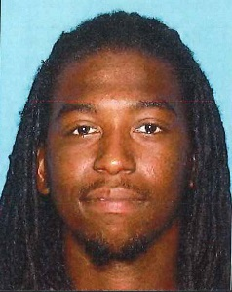
Shawn Craighead, 32, also of Lakewood, was charged with one Count of being a Certain Person Not to Possess a Weapon in violation of N.J.S.A. 2C:39-7b(1); one Count of Unlawful Possession of a Weapon in violation of N.J.S.A. 2C:39-5b(1); and one Count of Possession of Marijuana in violation of N.J.S.A. 2C:35-10a(4). Craighead is also lodged in the Ocean County Jail pending a detention hearing.

Prosecutor Billhimer and Chief Meyer would like to acknowledge the cooperation of the Ocean County Prosecutor’s Office Narcotics Strike Force and Asset Forfeiture Unit, the Ocean County Prosecutor’s Office Regional SWAT Team, the Lakewood Township Detective Bureau, Patrol Division and Special Response Team, the Toms River Police Department Emergency Services Unit and K-9 Unit, the Ocean County Sheriff’s Department K-9 Unit, the Barnegat Township Police Crime Reduction Unit, the Stafford Township Police Drug Enforcement Unit, and the Monmouth/Ocean County DEA HIDTA Group, for their collective efforts in bringing down this drug trafficking operation and arresting the individuals in question. “I can’t say enough about the collaborative efforts of all of the law enforcement agencies involved in this investigation. We will continue to work together to root out these drug dealers and prosecute them to the fullest extent of the law.”

The public and media are reminded that all defendants are innocent until proven guilty beyond a reasonable doubt in a court of law.

Follow the Office of the Ocean County Prosecutor online on Facebook, Twitter and Instagram.
The social media links provided are for reference only.
OCPO does not endorse any non-governmental websites, companies or applications.
For additional information, visit our Facebook Page at https://www.facebook.com/OCPONJ/

