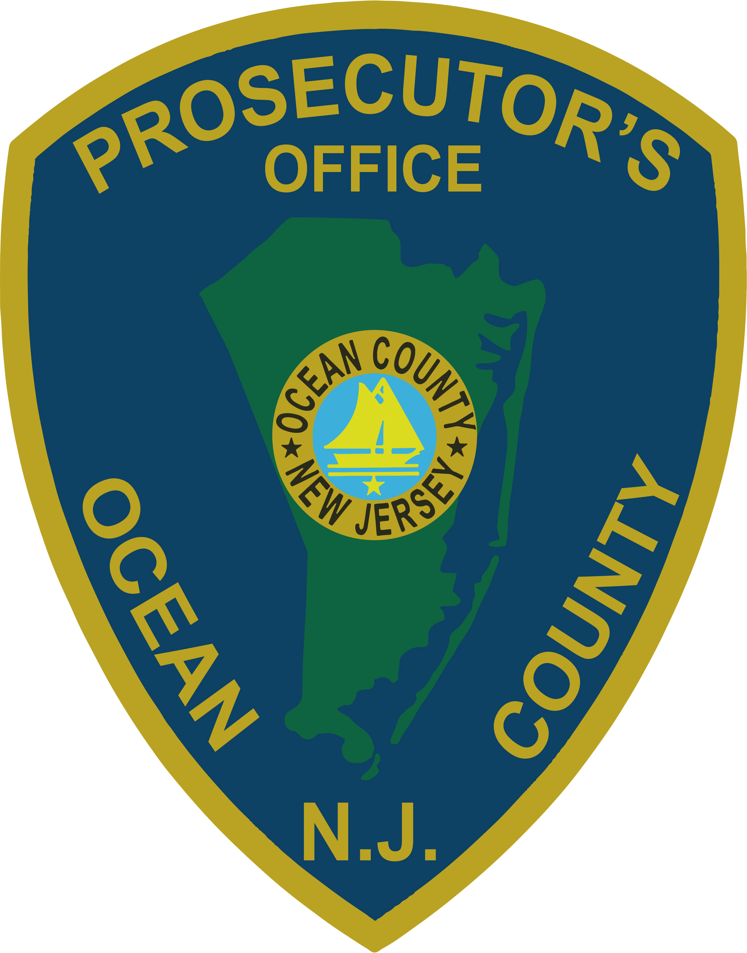 | PRESS RELEASE
FOR IMMEDIATE RELEASE  June 23, 2019 |  | CONTACT: Bryan Huntenburg  Ocean County Prosecutor’s Office  P.O. Box 2191  Toms River, NJ 08753  Office: (732) 929-2027  Mobile: (732) 288-6734  Email: ocpopress@co.ocean.nj.us

LAKEWOOD HOMICIDE UNDER INVESTIGATION

Ocean County Prosecutor Bradley D. Billhimer announced today that on Friday, June 21, 2019 at approximately 10:30 p.m., Lakewood Township Police responded to a residence in Lakewood for a report of a shooting inside the residence. Lakewood Township Police Officers found a 36 year-old male victim suffering from multiple gunshot wounds. The Ocean County Prosecutor’s Office Major Crime Unit and the Ocean County Sheriff’s Department Crime Scene Investigation Unit responded to the residence. The victim was transported to Monmouth Medical Center Southern Campus where he was pronounced dead.

This is an active and ongoing investigation by the Ocean County Prosecutor’s Office Major Crime Unit, Lakewood Township Police Department and the Ocean County Sheriff’s Department.

Follow the Office of the Ocean County Prosecutor online on Facebook, Twitter and Instagram.
The social media links provided are for reference only.
OCPO does not endorse any non-governmental websites, companies or applications.
For additional information, visit our Facebook Page at https://www.facebook.com/OCPONJ/

