 | PRESS RELEASE
FOR IMMEDIATE RELEASE  August 3, 2019 |  | CONTACT: Bryan Huntenburg  Ocean County Prosecutor’s Office  P.O. Box 2191  Toms River, NJ 08753  Office: (732) 929-2027  Mobile: (732) 288-6734  Email: ocpopress@co.ocean.nj.us

MASSAGE THERAPIST CHARGED WITH
ANOTHER SEXUAL ASSAULT

Ocean County Prosecutor Bradley D. Billhimer announced today that as a result of an ongoing investigation, Jonathan Higgins, age 28, of Toms River, has been charged again with Sexual Assault of another victim, in violation of N.J.S.A. 2C:14-2c(1). Higgins was arrested yesterday, August 2, 2019, in connection with a separate incident that occurred with another victim on May 21, 2019.
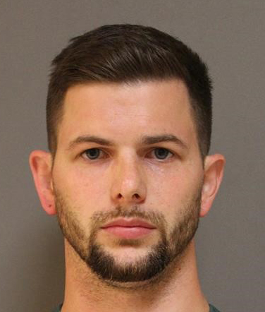
Prosecutor Billhimer alleges that Higgins, while employed as a massage therapist at Hand and Stone Massage & Facial Spa in Brick Township, committed an act of penetration on a female customer during the course of a massage on May 21, 2019. Higgins was previously arrested and charged with Sexual Assault on June 27, 2019. Yesterday’s arrest was a result of a continuing investigation by the Ocean County Prosecutor’s Office Special Victims Unit and the Brick Township Police Department.

Higgins was arrested and processed at Brick Township Police Headquarters. Higgins was transported to the Ocean County Jail where he is lodged pending a detention hearing.

Prosecutor Billhimer is urging anyone having information or who feels they may be a victim to please contact Detective Nicole Testa of the Ocean County Prosecutor’s Office at 732-929-2027 or Detective Timothy McCarthy of the Brick Township Police at 732-262-1100.

The public and media are reminded that all defendants are innocent until proven guilty in a court of law.

Follow the Office of the Ocean County Prosecutor online on Facebook, Twitter and Instagram.
The social media links provided are for reference only.
OCPO does not endorse any non-governmental websites, companies or applications.
For additional information, visit our Facebook Page at https://www.facebook.com/OCPONJ/

