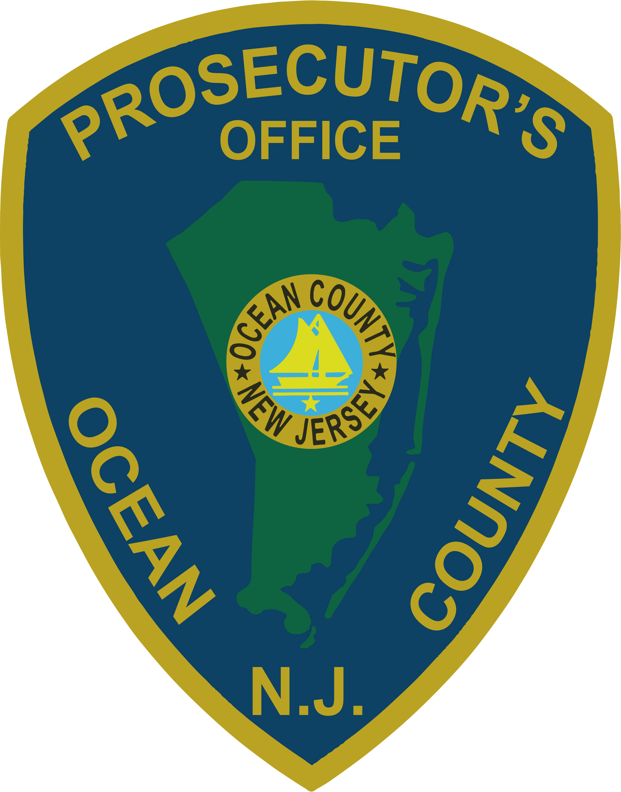 | PRESS RELEASE
FOR IMMEDIATE RELEASE  July14, 2019 |  | CONTACT: Bryan Huntenburg  Ocean County Prosecutor’s Office  P.O. Box 2191  Toms River, NJ 08753  Office: (732) 929-2027  Mobile: (732) 288-6734  Email: ocpopress@co.ocean.nj.us

PENNSYLVANIA WOMAN ARRESTED FOR DUI , ELUDING
& AGGRAVATED ASSAULT ON POLICE OFFICERS


Ocean County Prosecutor Bradley D. Billhimer announced that on Saturday, July 13, 2019, Jessica Hayes, age 30, of Bensalem, Pennsylvania was arrested and charged with Driving Under the Influence in violation of N.J.S.A. 39:4-50, Eluding in violation of N.J.S.A. 2C:29-2, three counts of Aggravated Assault in violation of N.J.S.A. 2C:12-1b(5), Resisting Arrest in violation of N.J.S.A. 2C:29-2a(3) and Obstructing the Administration of Law in violation of N.J.S.A. 2C:29-1a. Hayes was also charged with additional motor vehicle violations.

On Saturday, July 13, 2019, Seaside Park Police were summoned to the Wells Fargo Bank on Northeast Central Avenue in regard to a suspicious female in the bank, later identified as Jessica Hayes. As Seaside Park Police Officers were speaking to Hayes, a New Jersey State Park Police Officer arrived and advised that he had attempted to stop Hayes as she was leaving Island Beach State Park. The New Jersey State Park Police Officer witnessed Hayes operating a blue Hyundai in Island Beach State Park. Hayes was traveling in excess of 70 miles per hour in a 35 mile per hour zone. Hayes ignored commands to pull over and continued out of Island Beach State Park at a high rate of speed. Hayes continued north on Central Avenue into Seaside Park, reaching speeds of 60 miles per hour while weaving in and out of traffic. Due to the substantial risk of injury to the public, the New Jersey State Park Police Officer terminated his pursuit.

Hayes displayed signs of intoxication and field sobriety tests were performed at the bank. While attempting to place Hayes under arrest, she resisted and assaulted two Seaside Park Police Officers and one New Jersey State Park Police Sergeant. Hayes was eventually arrested without further incident. Officers subsequently obtained a Blood Warrant to determine Hayes’ level of intoxication.

“It’s my understanding that Hayes caused minor injuries to two Seaside Park Police Officers and that she actually bit a State Park Police Sergeant on his leg” Prosecutor Billhimer stated. “Quite frankly, we are lucky no one else was injured by her reckless behavior on a very busy Saturday at the Jersey Shore. All of the Officers involved did a great job and it looks like they will all be ok. Hayes is being evaluated at a local hospital, she will be transported to the Ocean County Jail once she is medically cleared” Prosecutor Billhimer added.

Prosecutor Billhimer would like to thank the Seaside Park Police, New Jersey State Park Police and the New Jersey State Police for their diligent efforts in the apprehension of Hayes and for their efforts in preserving the safety and well-being of the many families that were enjoying a beautiful Saturday at the Jersey Shore.

The public and media are reminded that all defendants are innocent until proven guilty in a court of law.

Follow the Office of the Ocean County Prosecutor online on Facebook, Twitter and Instagram.
The social media links provided are for reference only.
OCPO does not endorse any non-governmental websites, companies or applications.
For additional information, visit our Facebook Page at https://www.facebook.com/OCPONJ/

