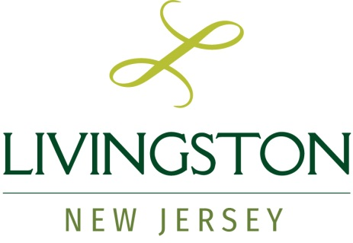
For Immediate Release
March 29, 2021
Contact: Judith A. Heller
jheller@livingstonnj.org
973-992-5000 ext. #5307

Mayor’s COVID Physician Advisory Board to Assist Health Department

Meet the Board Members

(Livingston, NJ) – Livingston Mayor Shawn Klein has created a COVID Physician Advisory Board (PAB) to serve in an advisory capacity for the Township and its Health Department.
The goal of forming the PAB is to provide additional medical expertise to assist Livingston Township Health Officer Lou Anello as Livingston works through the process of “opening up.” The Township will continue to look to the Health Officer and Health Department for guidance as the vaccine rollout progresses.
Most of what the Health Officer recommends to the Township Council or Board of Education is dictated by the State of New Jersey; however, there is still room in some cases for judgments to be made. The PAB members will be a resource here, providing insight and advice within their areas of expertise.
The members of the Mayor’s COVID Physician Advisory Board are:
Kerry S. LeBenger, MD, FAAAAI, FACAAI is Chair of Medical Specialties at Summit Health (formerly Summit Medical Group / City MD) and a clinical immunologist. He is responsible for coordinating the COVID response for Summit Health. Dr. LeBenger attended New York Medical College for his MD and completed his residency at Lenox Hill Hospital and his Allergy and Immunology fellowship at New York Hospital/Cornell Medical Center.
Steven Sheris, MD, FACC, FACP is Senior Vice President, Physician Enterprise at Atlantic Health System and President of Atlantic Medical Group. He is a cardiologist with Associates in Cardiovascular Disease in New Providence, NJ. Dr. Sheris completed his MD at UMDNJ – Rutgers Medical School, residency and Cardiovascular Diseases fellowship at National Naval Medical Center, and Cardiac Ultrasound fellowship at Georgetown University Medical Center.
Eric Handler, DO, FACEP is Interim Chairman of the Emergency Department at Saint Barnabas Medical Center. He received his Doctor of Osteopathy (DO) degree from Nova Southeastern University College of Osteopathic Medicine and completed his internship at UMDNJ – St. Francis Hospital and residency at Newark Beth Israel Medical Center.
Livingston Township Health Officer Anello and his staff have been advising, supporting, and working to keep the Livingston community safe since the beginning of the COVID-19 pandemic. Anello and Mayor Klein recognized the efforts of the Health Department staff.
“Lou Anello and our Health Department have been working tirelessly throughout the last year — communicating with the public about health information and safety guidelines, assisting with contact tracing, supporting the Essex County vaccination site in Livingston, and much more,” stated Mayor Klein. “We are grateful for their hard work and dedication.”
Both the State of New Jersey and the County of Essex provide guidelines to be followed and requirements to be met in handling issues relating to COVID-19. Final recommendations in any situation relating to the Township’s Health Department messages, actions, or policies will be made by Health Officer Lou Anello.
# # #

