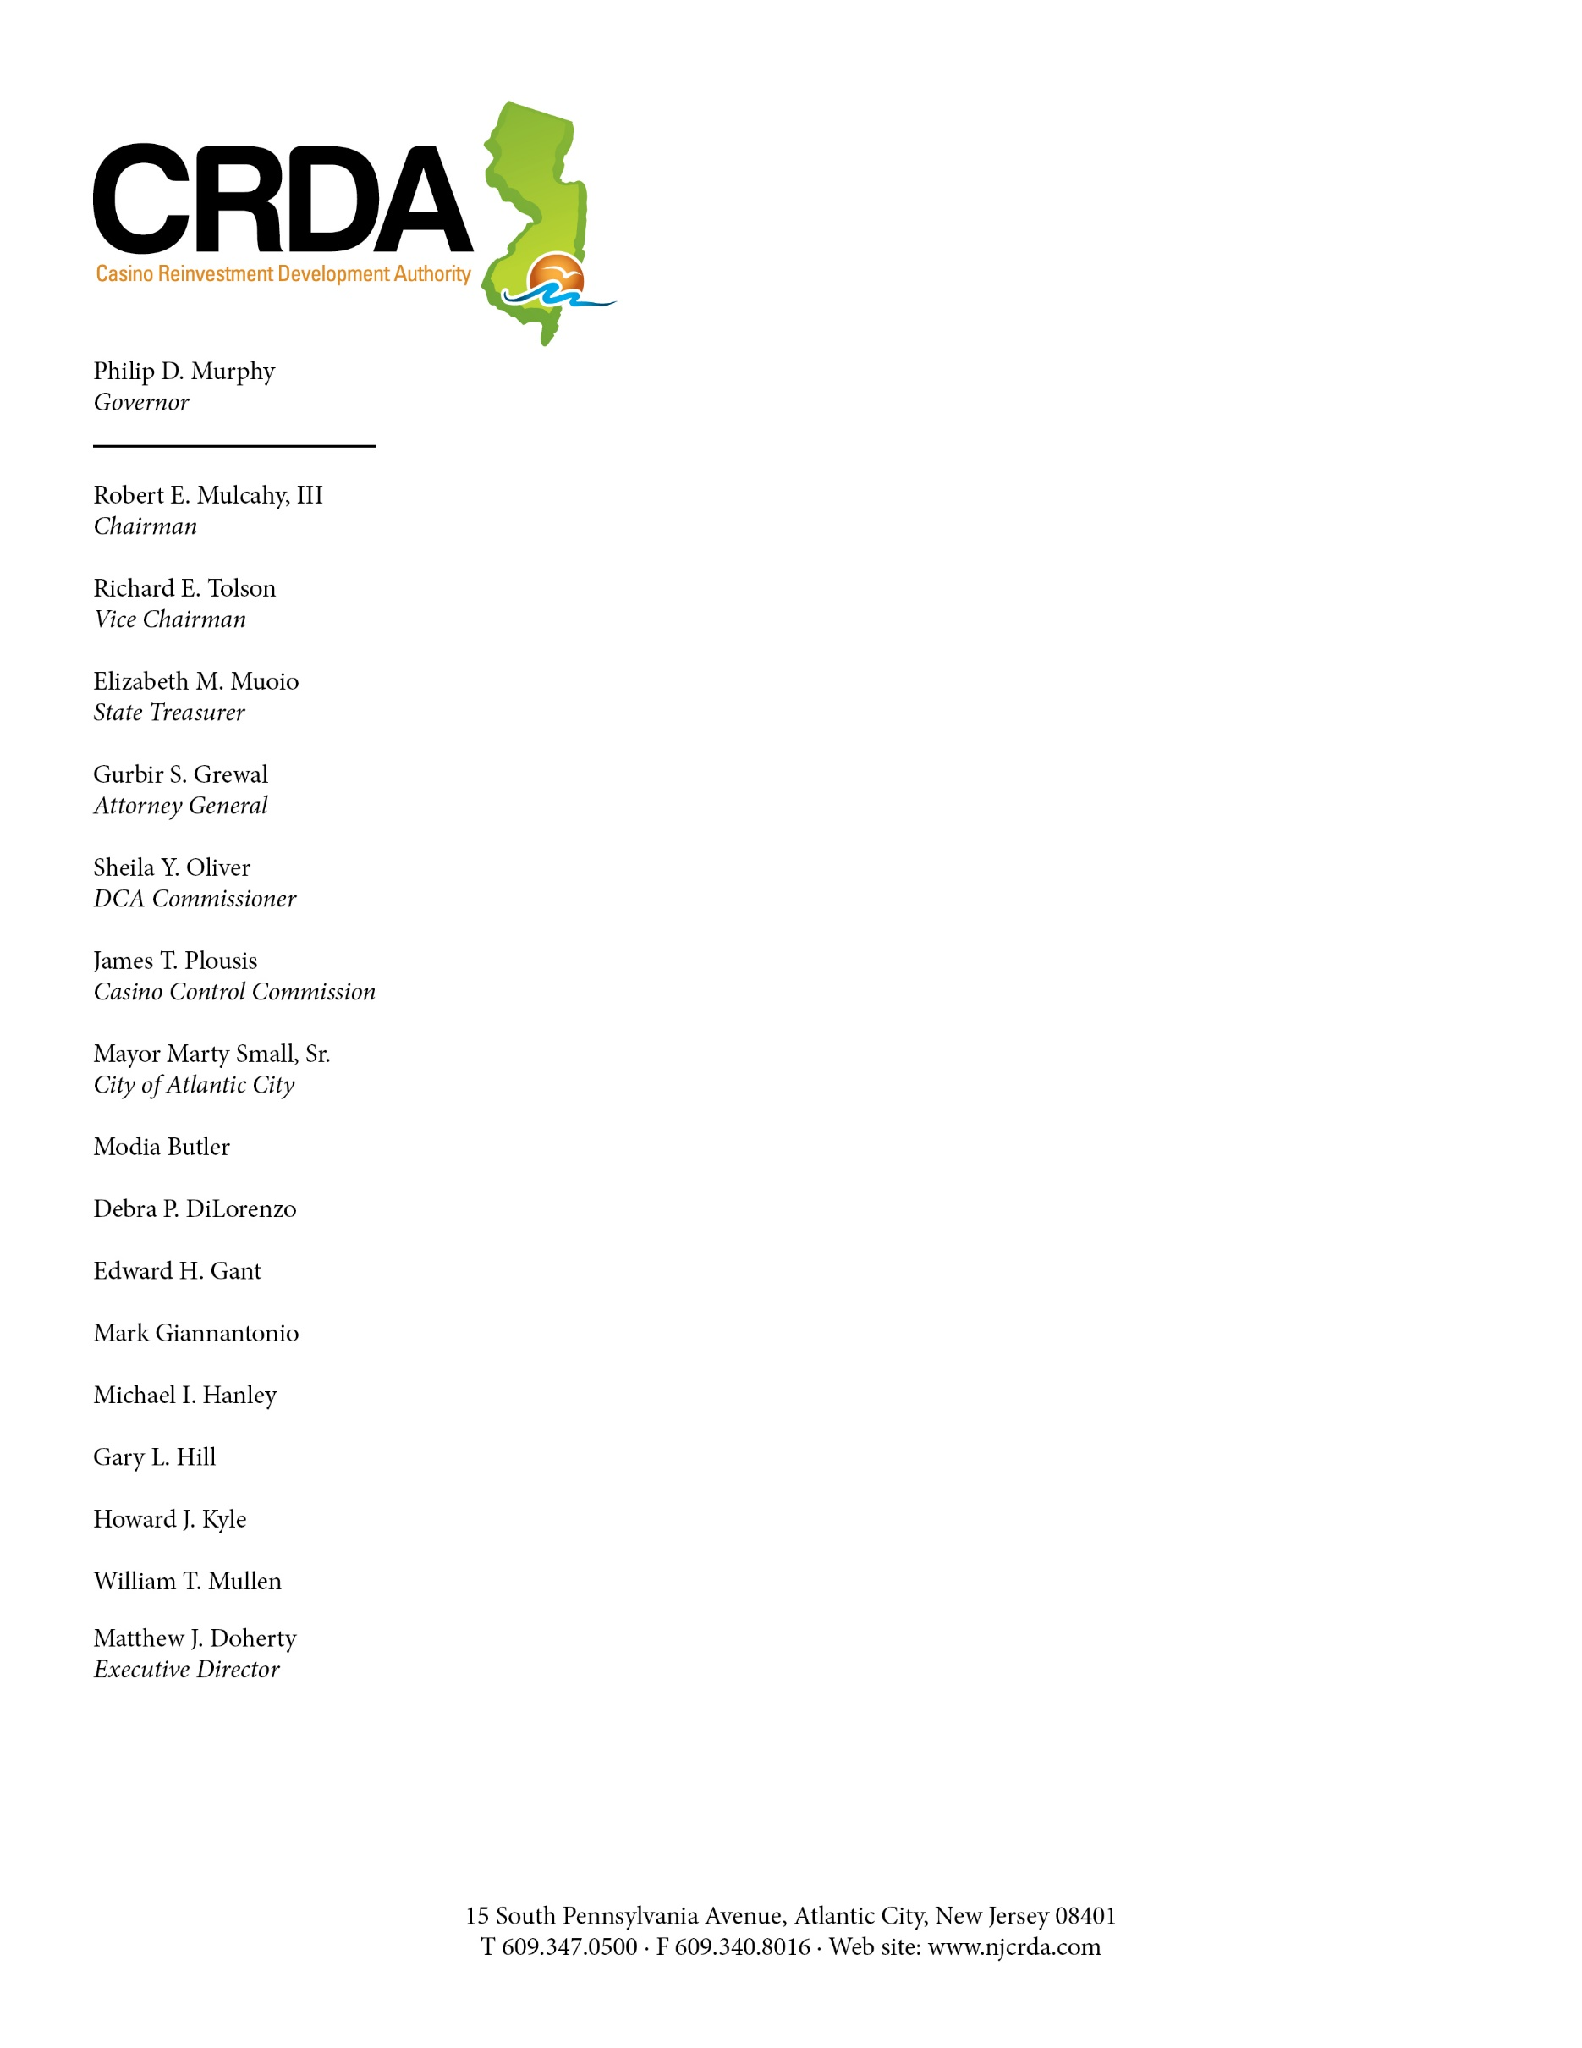
January 6, 2021

SENT VIA EMAIL ONLY
opra+request-19364-761603f9@requests.opramachine.com
AC Lover

Re: OPRA Request No. 2021-01-001

Dear Sir/Madam:

I am in receipt of your request for government records submitted pursuant to the Open Public Records Act, N.J.S.A. 47:1A-1 et seq. and received by the Casino Reinvestment Development Authority (“CRDA”) on Monday, January 4, 2020. Your request has been assigned tracking number 2021-01-001.

Please note all available application materials submitted for approval by CRDA zoning and planning professionals, including but not limited to site plans, materials related to condition use approval, etc. for the vacant lot at 206 South Vermont Avenue can be found on our website at www.njcrda.com under the heading “Applications and Public Notices,” “Submitted Land Use Development Applications” then “Estate of AC Application #2016-08-2029.” You may also copy and paste the following link: https://njcrda.com/applications-and-public-notices/estate-ac-application-2016-08-2029/.

Please also confirm by January 13, 2021 whether access to the documents on CRDA’s website satisfies your request. If not, CRDA will provide the documents requested by you via email attachment.

Thank you.

Sincerely,

Ellen M. Edwards

Ellen M. Edwards
Paralegal/Records Custodian

encl.

