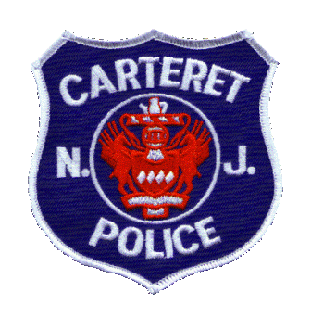

Carteret Police Department
230 Roosevelt Avenue
Carteret, N.J. 07008
(732) 541-4181

Chief of Police
Dennis McFadden

April 1, 2021

Dear Mr. Radwan,
The Carteret Police Department received your OPRA Records Act (NJSA 47:1A-1) on dated March 4, 2021.The Carteret Police Department’s Official Records Custodian, Captain Jeffrey VanWoeart received your OPRA Records Act (NJSA 47:1A-1) on March 4, 2021. After filing an extension this response is being provided on the Sixth (6th) business day since the Carteret Police Departments records custodian received said request.
The following specific records have been requested:
Call logs from Lt John Kelly cell phone number 732-379-1932 from 9/1/2020 to 10/24/2020
Record responsive to this request has been located and supplied. All redactions were made to unlisted phone numbers.
N.J.S.A. 47:1A-1 Privacy Interest-a public agency has a responsibility and an obligation to safeguard from public access a citizen’s personal information with which it has been entrusted when disclosure thereof would violate the citizen reasonable expectation of privacy
If your request for access to a government record has been denied or unfilled within seven (7) business days by law, you have the right to challenge the decision by the Carteret Police Department to deny access. At your option, you may either institute a proceeding in the Superior Court of New Jersey or file a complaint with the Government Records Council (GRC) by completing the Denial of Access Complaint form. In addition to the website, information can be obtained from GRC Staff by email Government.Records@dca.nj.gov, toll-free phone number (866-855-0511), fax (609-633-6337), or by US mail at PO Box 819, Trenton, New Jersey, 08625-0819. OPRA prepared by Records Clerk Jasbir Judge on behalf of Captain Jeffrey VanWoeart.
Respectfully,
Captain Jeffrey VanWoeart
Jasbir Judge

