

David Fried, Mayor
2298 Route 33 Robbinsville, NJ 08691
(609) 259-3600 ext. 1102

COUNTY OF MERCER
STATE OF NEW JERSEY

EXECUTIVE ORDER 2023-27

I, David Fried, Mayor of the Township of Robbinsville, Mercer County, hereby appoint Danielle Spilatore Municipal Asset Officer within the Department of Administration effective May 1, 2023, at an annual salary of $60,000.00 charged 50% to 3-01-20-110-001-101 and 50% to 3-01-20-100-000-101.

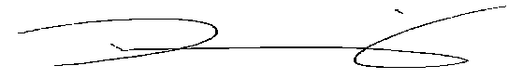
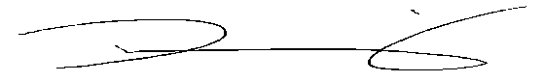
________________________
DAVID FRIED, MAYOR

DATED: April 24, 2023

