Click on the following link for NJSTART: https://www.njstart.gov

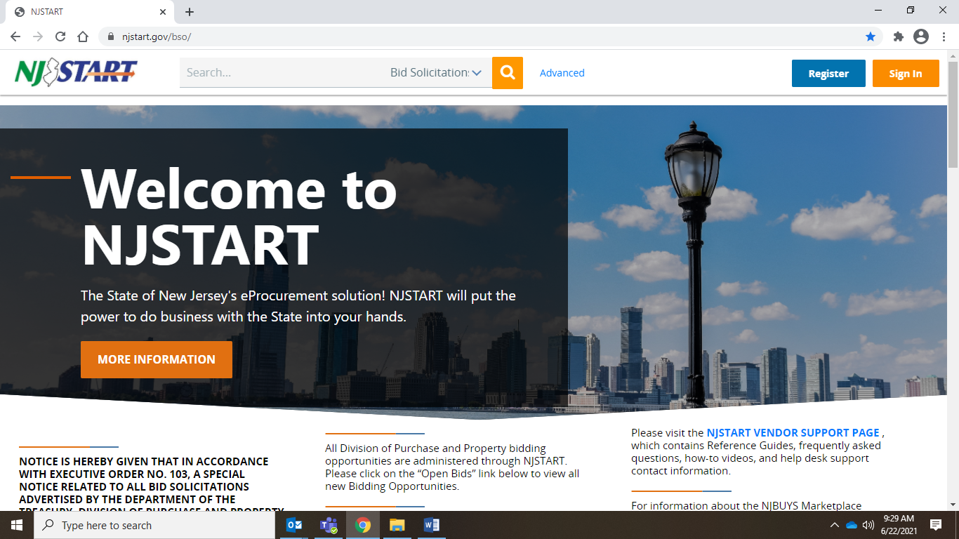

In the search box type M2001, in the drop down box click Contracts, and search (magnifying glass). Click on the Contract number(s) for additional documents located in Agency Attachments.

