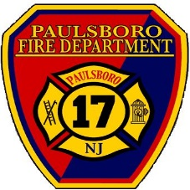
PAULSBORO FIRE DEPARTMENT
1211 N. Delaware Street
Paulsboro, New Jersey 08066
Office of the Chief

12/17/2021
Kathy,

Per your OPRA request filing for the Month of November 2021 the Paulsboro Fire Department did not have any fire calls with property damaged. If they want they can follow up with the Gloucester County Fire Marshall Office in Clayton.

Respectfully,

Michael A. Licciardello
Chief Paulsboro Fire Department

