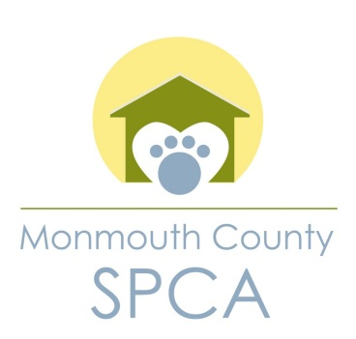
MEMORANDUM OF UNDERSTANDING
BETWEEN
MONMOUTH COUNTY S.P.C.A
AND
BOROUGH OF TINTON FALLS
FOR
TRAP, NEUTER AND RELEASE PROGRAM

WHEREAS, the Monmouth County S.P.C.A, being a duly authorized animal shelter under the authority of New Jersey State Law Title 4, and having such authority within the County of Monmouth to act as so, shall enter into a “Memorandum of Understanding (MOU)” for a “Trap, Neuter and Release (TNR)” program with the Borough of Tinton Falls, being a duly authorized Municipality within the County of Monmouth.
WHEREAS, the Monmouth County SPCA shall assume the role as the approved sponsor for the TNR program within the Borough of Tinton Falls and shall set forth the requirements for this program which shall be listed in this MOU.
WHEREAS, the Monmouth County SPCA shall provide the Borough of Tinton Falls with a certificated of insurance naming the Borough of Tinton Falls as additionally insured.
The following guidelines shall be set forth and be agreed upon by both the Monmouth County SPCA and the Borough of Tinton Falls.
I. Monmouth County SPCA sponsorship requirements:
- Review and approve colony caregivers
- Schedule surgical dates for all TNR activities
- Maintain records provided by colony caregivers
- Maintain all medical records
- Set TNR standards and guidelines
- Be responsible with the Borough for humanely trapping, neutering, vaccinating and spaying or neutering of feral cats

(2)

II. The established fee to TNR a feral cat for this program shall be $75.00. The Borough of Tinton Falls shall be responsible for $37.50 of this cost while the Monmouth County SPCA shall be responsible for $37.50. The fee for this program shall include the neutering, ear tip, rabies vaccination and micro-chip for each cat. The Monmouth County SPCA shall bill the Borough of Tinton Falls monthly with a detailed list of activities. There shall be a limit of 150 cats per year under this program or until funding for this program expires.

III. The Monmouth County SPCA shall designate a member of the SPCA to serve as the TNR representative for the program and shall coordinate all TNR activities with the Borough of Tinton Falls’ appointed designate. The appointed Borough and appointed SPCA designate shall maintain an open channel of communications with Borough Officials as well as Monmouth County SPCA Officials.

IV. The Monmouth County SPCA, the Borough of Tinton Falls Animal Control Officer and approved caregivers shall coordinate the transportation, to and from the Monmouth County SPCA for the purpose of this TNR program. The Monmouth County SPCA reserves the right not to release any cat that is deemed adoptable and to offer that cat up for private adoption from the shelter.

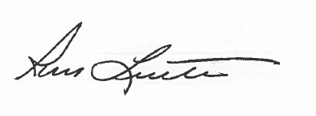
This memorandum of understanding may be canceled by either party. A thirty (30) day notice of cancelation must be provided by the canceling party.

_____________________________________ 1/1/2020
Ross F. Licitra-Chief of Police-Executive Director

______________________________________
Borough of Tinton Falls-Official

