MONMOUTH BEACH POLICE DEPARTMENT
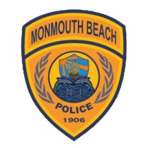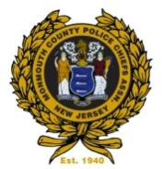
14 Willow Avenue
Monmouth Beach, NJ 07750
1-732-229-1313
Thomas C. Walsh December 6,2017
Chief of Police

Public Synopsis of Disciplinary Actions for Internal Affairs for 2016
IA CASE QUARTER HOW REPORTED COMPLAINT TYPE DISPOSITION
IA1601 1 Citizen Complaint Rules Violation Sustained
IA1602 2 Citizen Complaint Rules Violation Sustained
IA1603 3 Agency Department Rules Violation Unfounded

