MONMOUTH BEACH POLICE DEPARTMENT
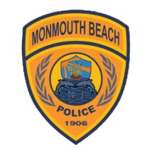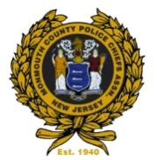
14 Willow Avenue
Monmouth Beach, NJ 07750
1-732-229-1313
Thomas C. Walsh December 6,2017
Chief of Police

Public Synopsis of Disciplinary Actions for Internal Affairs for 2015
IA CASE QUARTER HOW REPORTED COMPLAINT TYPE DISPOSITION
IA1501 1 Agency Other Rule Violation Exonerated
IA1502 2 Citizen Complaint Other Rule Violation Not Sustained
IA1503 2 Agency Department Rule Violation Sustained
IA1504 2 Agency Department Rule Violation Sustained
IA1505 3 Citizen Complaint Other Violation Exonerated
IA1506 4 Citizen Complaint Other Violation Not Sustained

