

September 12, 2022
Regina Discenza
No mailing address provided
Regina Discenza opra+request-34948-580b6586@requests.opramachine.com

Dear Regina Discenza,

The New Jersey School Boards Association received your Open Public Records Act (OPRA) request on August 26, 2022. The official Records Custodian, Carl Tanksley, Jr., Esq. received your OPRA request on August 29, 2022. As such, the seven (7) business day deadline to respond to your request is September 12, 2022 (exclusive of NJSBA’s summer schedule and the intervening holiday). This response to your request is being provided to you on the 10th business day after the custodian’s receipt of said request.

The following records are being provided in their entirety and are responsive to your request.

- NJSBA Transcript for Lacey Board Members Harold "Skip" Peters, one (1) page.
- NJSBA Transcript for Lacey Board Members Frank Palino, one (1) of page.

These records are being transmitted to you via email to opra+request-34948-580b6586@requests.opramachine.com, as per your request. Pursuant to N.J.S.A. 47:1A-5.b., the cost associated with this request is $0.00.

If your request for access to a government record has been denied or unfilled within the seven (7) business days required by law, you have a right to challenge the decision by the NJSBA to deny access. At your option, you may either institute a proceeding in the Superior Court of New Jersey or file a complaint with the Government Records Council (GRC) by completing the Denial of Access Complaint Form. You may contact the GRC by toll-free telephone at 866-850-0511, by mail at P.O. Box 819, Trenton, NJ, 08625, by e-mail at grc@dca.state.nj.us, or at their web site at www.state.nj.us/grc. The GRC can also answer other questions about the law. All questions regarding complaints filed in Superior Court should be directed to the Court Clerk in your County.
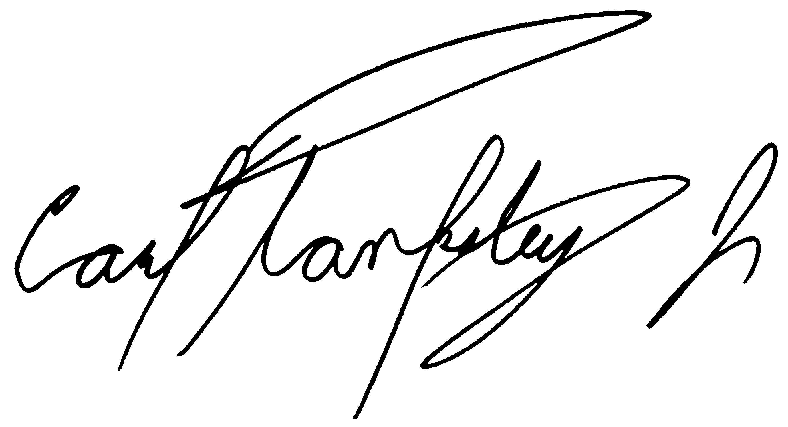
Sincerely,

Carl Tanksley Jr., Esq., Acting Records Custodian
New Jersey School Boards Association
413 West State Street
Trenton, New Jersey 08618
Office - (609) 278-5245
ctanksley@njsba.org
http://www.njsba.org/
http://www.facebook.com/njsba
http://www.twitter.com/njsba
www.youtube.com/njsba
www.instagram.com/njschoolboards

