November 14, 2019

VIA E-MAIL
Anonymous
opra+request-7899-44e95470@requests.opramachine.com

RE: OPRA REQUEST

Dear Sir or Madam:

We received your Open Public Records Act (OPRA) request via e-mail on November 7, 2019 seeking:

“A copy of application for a Letter of Interpretation for Pinelands Development Credits, Jackson, Block 23001, lots 22-29 Jackson Trails.”

The Pinelands Commission does not possess any documents responsive to this request.

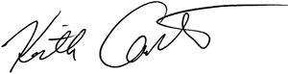
Sincerely,

Keith M. Carter
Regulatory Programs Specialist/Records Custodian

