November 19, 2019

VIA E-MAIL
Anonymous
opra+request-7961-1952ebc2@requests.opramachine.com

RE: OPRA REQUEST

Dear Sir or Madam:

We received your Open Public Records Act (OPRA) request via email on November 12, 2019. Specifically, your requests seek:

“Copy of Pinelands Commission consistent certificate of filing of Jackson Trails.”

Attached are the documents responsive to your request.

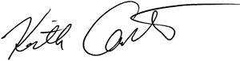
Sincerely,

Keith M. Carter
Regulatory Programs Specialist/Records Custodian

