PINELANDS REGIONAL SCHOOL DISTRICT


520 Nugentown Road
P.O. Box 248
Little Egg Harbor, NJ 08087-0248

Telephone 609-296-3106
Fax 609-294-8770
MELISSA A. McCOOLEY, Ed.D.
Superintendent

AMANDA P. MILLER
Business Administrator/Board Secretary

June 5, 2023

Dear Paul Dalnoky,

As you are aware, I am the Business Administrator for the Pinelands Regional Board of Education (the “Board”), which conducts and supervises the schools of the Pinelands Regional School District (the “District”). As such, I am in receipt of your May 26, 2023 OPRA request which sought the following:

True copies of the blueprints for the renovations of the Pinelands Regional High School which occurred in the period between 2017-2020.

The seventh business day to respond to this request is June 6, 2023. I am writing to inform you I will need an extension of time to respond to your request, to locate documents which may be potentially responsive, and determine if same are subject to disclosure. OPRA allows for the Records Custodian to advise of the need for an extension pursuant to N.J.S.A 47:1A-5.i. Specifically, OPRA states that, “the requestor shall be advised by the custodian when the record can be made available. This extension is until July 6, 2023. If the record is not made available by that time, access shall be deemed denied.”

Sincerely,
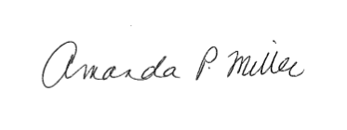

Amanda Miller
Business Administrator/Board Secretary

