PINELANDS REGIONAL SCHOOL DISTRICT


MELISSA A. McCOOLEY, Ed.D.
Superintendent

AMANDA P. MILLER
Business Administrator/Board Secretary

520 Nugentown Road
P.O. Box 248
Little Egg Harbor, NJ 08087-0248

Telephone 609-296-3106
Fax 609-294-8770

Paul Dalnocky
opra+request-34732-8490e40e@requests.opramachine.com

Dear Mr. Dalnocky

As you are aware, I am the Business Administrator for the Pinelands Regional Board of Education (the “Board”), which conducts and supervises the schools of the Pinelands Regional School District (the “District”). As such, I am in receipt of your August 16, 2022 request, to which I previously advised I would need an extension until September 22, 2022. Your request sought the following:

All documents reflecting any communication with the New Jersey Schools Insurance Group which concern my claims against your district.
I am constrained to deny your request as this type of information is expressly exempt pursuant to N.J.S.A. 47:1A-9, and GRC Exemption Number 13, which exempts:

- Information which is a communication between a public agency and its insurance carrier, administrative service organization or risk management office.

In your OPRA request you indicated that your preferred method to receive communications from the Board is through email. Therefore, this letter is being sent to you via email. If I can be of any further assistance, please do not hesitate to contact me.

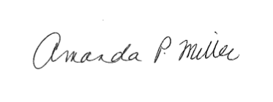
Sincerely,

Amanda P. Miller
Business Administrator/Board Secretary

