October 17, 2022

VIA E-MAIL
Patrick Duff
opra+request-35909-4a251590@requests.opramachine.com

RE: OPRA REQUEST

Dear Mr. Duff:

We received your Open Public Records Act (OPRA) request via e-mail on October 7, 2022. Specifically, your request seeks:

“Communications from 1-1-22 through today with Medford Officials regarding redevelopment of 17-19 N Main St. To include emails, letters, memos, attachments to emails and responses to any surveys of the property.”

Attached is the document responsive to your request.

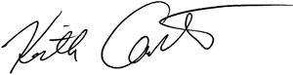
Sincerely,

Keith M. Carter
Regulatory Programs Specialist/Records Custodian

