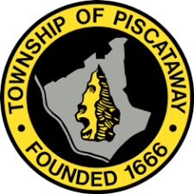
The Piscataway Township Civil Rights Advisory Commission,
In commemoration of
Rev. Dr. Martin Luther King, Jr. 2021 Celebration

Presented to

Julia Amaker Porterfield
Entrepreneur/Community Leader

THE “TRAILBLAZER AWARD”

For a life lived with Strength, Courage and Resilience in the relentless
pursuit of goals to improve and benefit the lives of everyone.
We honor you on this 18th day of January in the year of 2021.
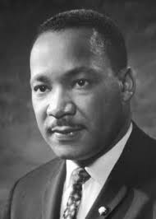
Mayor Brian C. Wahler
Rev. Dr. Kenneth L. Saunders, Sr., Chairman

“Through it all, Yet we Stand!”

