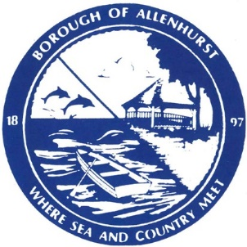
BOROUGH OF ALLENHURST
125 Corlies Avenue
Allenhurst, NJ 07711
Phone (732) 531-2757 Fax: (732) 531-8694
www,allenhurstnj.org

David J. McLaughlin – Mayor
Christopher J. McLoughlin – Deputy Mayor
Terrence J. Bolan – Commissioner
Donna M. Campagna – Clerk/ Administrator

Glenn Michalowski
opra+request-20684-1ac8caf2@requests.opramachine.com

Dear Glenn Michalowski:

The Borough of Allenhurst received your Open Public Records Act (OPRA) request on April 20, 2021. The custodian of the requested documents was in receipt of your request on April 20, 2021, as well. As such, the seven (7) business day deadline to respond to your request is April 29, 2021. This response is being sent to you on the first business day after the custodian’s receipt of said request.

Your OPRA request sought the following records:
“If your municipality has a police civilian review board, or police citizen advisory board could you please provide a copy of the ordinance/resolution that formed the board and their by-laws.

Please provide this document via e-mail either as a pdf or if the information can be found on your website, a link to the page where this information can be found.”

There are no records responsive to your request as the Borough does not have a Police Civilian Review Board.

If your request for access to a government record has been denied or unfilled within the seven (7) business days required by law, you have a right to challenge the decision by the Borough of Allenhurst to deny access. At your option, you may either institute a proceeding in the Superior Court of New Jersey or file a complaint with the Government Records Council (GRC) by completing the Denial of Access Complaint Form. You may contact the GRC by toll-free telephone at 866-850-0511, by mail at P.O. Box 819, Trenton, NJ, 08625, by e-mail at grc@dca.state.nj.us, or at their web site at www.state.nj.us/grc. The GRC can also answer other questions about the law. All questions regarding complaints filed in Superior Court should be directed to the Court Clerk in your County.

Sincerely,
Donna M. Campagna
Donna M. Campagna, RMC
Administrator/Clerk
dcampagna@allenhurstnj.org

